**BC Q301 CH5: LESSON 1A AREA and INTEGRAL CONNECTION**

**Area – Integral Connection and Riemann Sums**

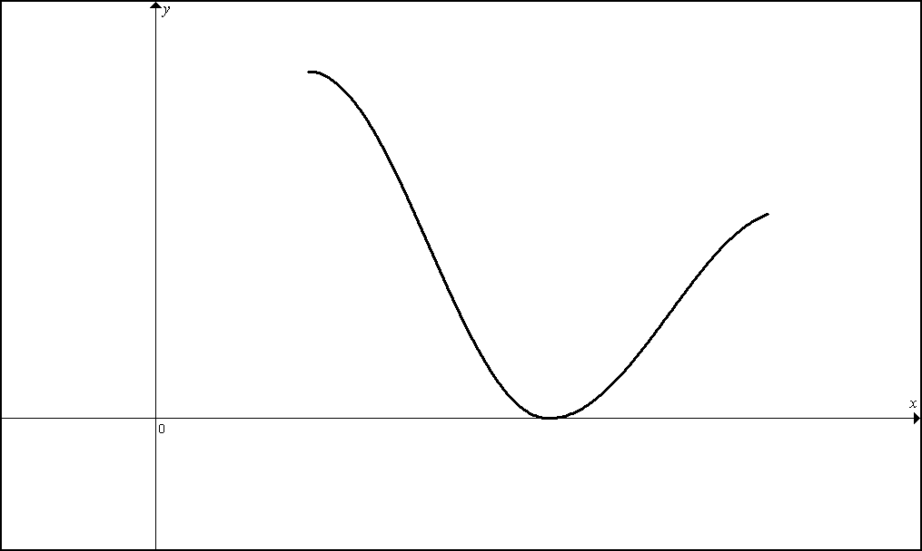

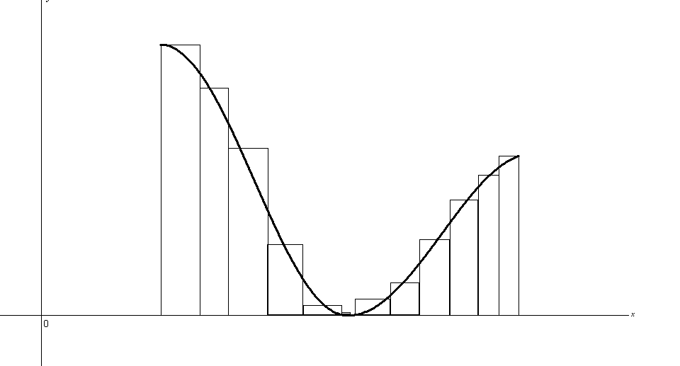

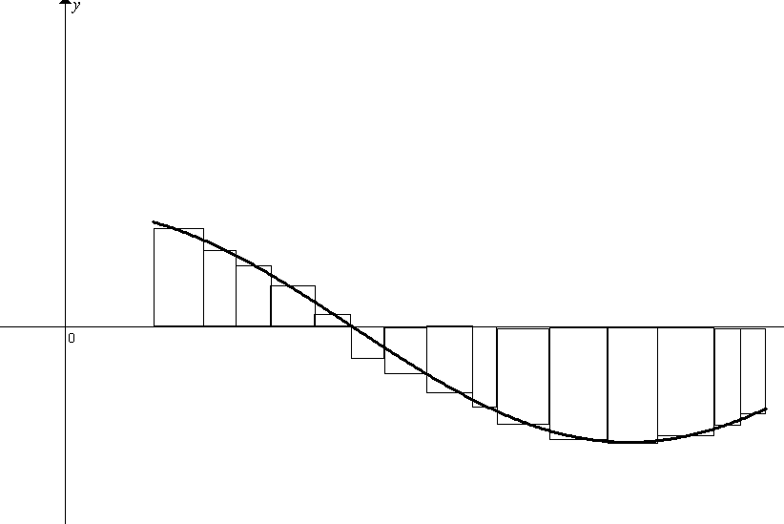**I. INTEGRAL AND AREA – BY HAND (APPEAL TO GEOMETRY)**

NOTES: Below are graphs that each represent a different *f*(*x*) from *x* = -3 to *x* = 4.

A] Find the Area bounded by the graph of *f* and the *x*-axis.   
B] Evaluate the integral. Express the integral as it relates to a collection of areas.

C] Express the Area as it relates to an (or set of) integral(s).

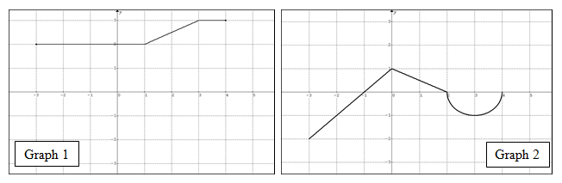

PRACTICE

1. The graph of is made up of line segments and semi-circles as shown in the graph below.

Evaluate A – E.

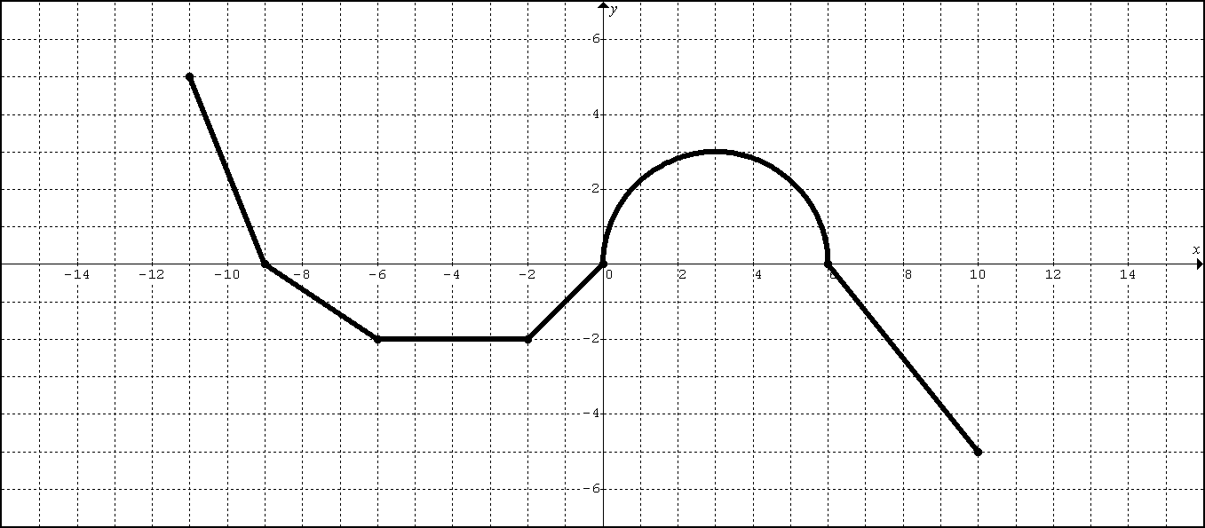

A. Find the total area bounded by the graph of and the *x*-axis.

B. 

C. 

D. 

E. 

2. The graph of is made up of line segments and semi-circles as shown in the graph below.

Evaluate A – E.

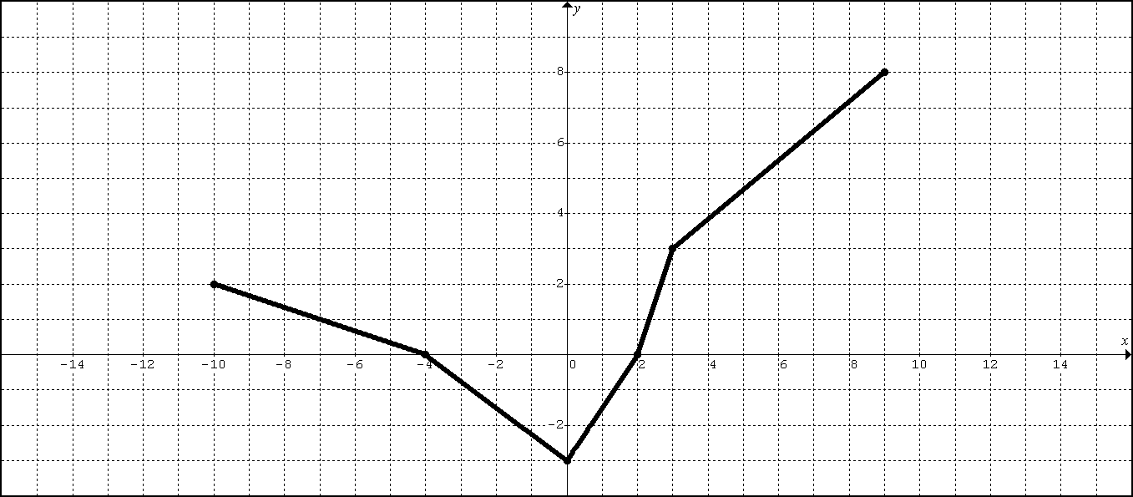

A. Find the total area bounded by the graph of and the *x*-axis.

B. 

C. 

D. 

E. 

3. Evaluate each integral by appealing to geometry.

A.  B. **II. CH5 – (INTEGRAL PROPERTIES):**

Suppose that *f* and *h* are continuous functions and that

, , and .

Find each integral below:













**BC: Q301 CH5A – LESSON 1A HOMEWORK**

1.

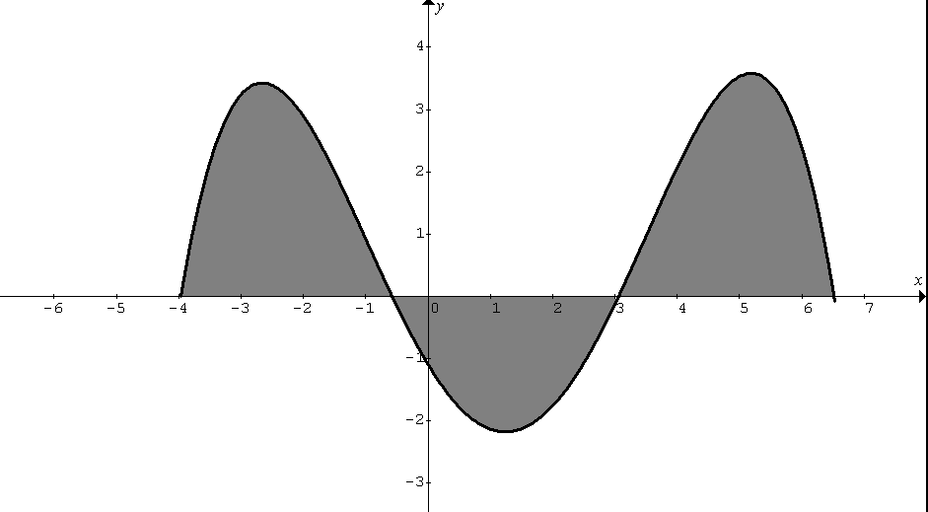

A3

A2

A1

In the diagram above, the values of the areas A1, A2, and A3 bounded by the graph of and the *x*-axis, are 7, 5, and 8 square units respectively. has zeros at -4, -0.6, 3, and 6.5.

Calculate the following definite integrals:

A. 

B. 

C. 

D. 

2. The graph of is made up of line segments and semi-circles as shown in the graph below.

Evaluate A – E.

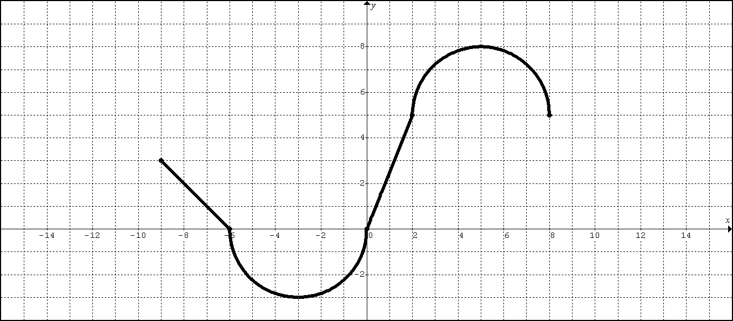

A. Find the total area bounded by the graph of and the *x*-axis.

B. 

C. 

D. 

E. 

3. The graph of is made up of line segments and semi-circles as shown in the graph below.

Evaluate A – E.

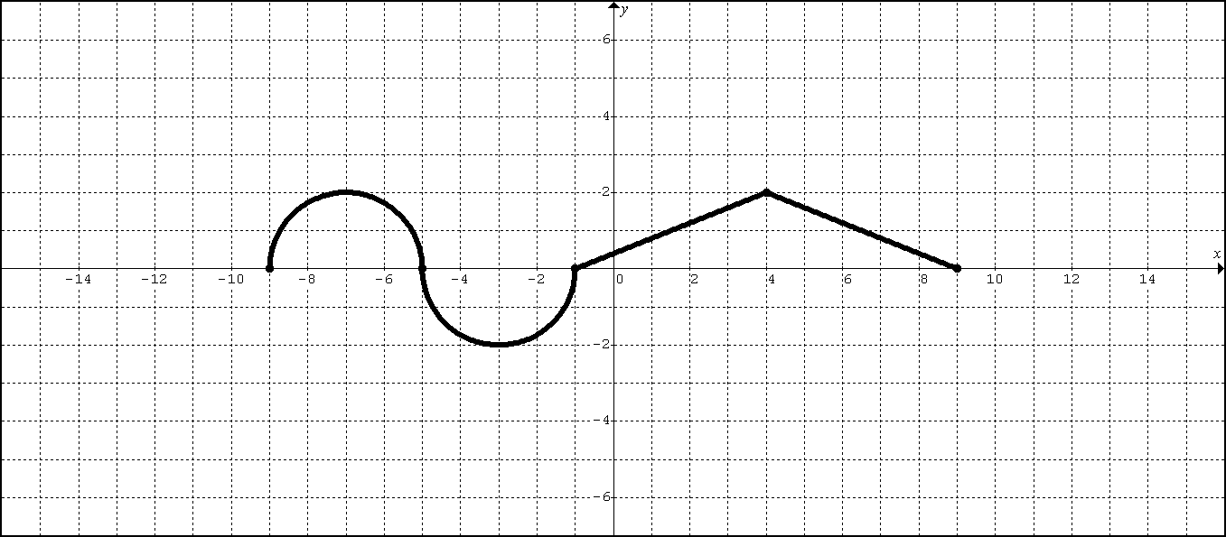

A. Find the total area bounded by the graph of and the *x*-axis.

B. 

C. 

D. 

E. 

4. Evaluate the following by appealing to geometry.

A.  B. 

5. Suppose that *f* and *g* are continuous functions and that …

, , and 

Evaluate each of the following integrals:

A. 

B. 

C. 

D. 

E. 

F. 

**BC Q301 CH5: LESSON 1B AREA/INTEGRAL/FTC2**

**FTC2: Fundamental Theorem of Calculus (Part II) – Evaluation Method**

I. [**FTC2-INTEGRAL**] Evaluate the following integrals (a) BY HAND and (b) BY TI89

II. [**FTC2- AREA**]

1. Find the area bounded by  and the *x*-axis on the interval [0, 2]

(a) BY HAND (b) BY TI89

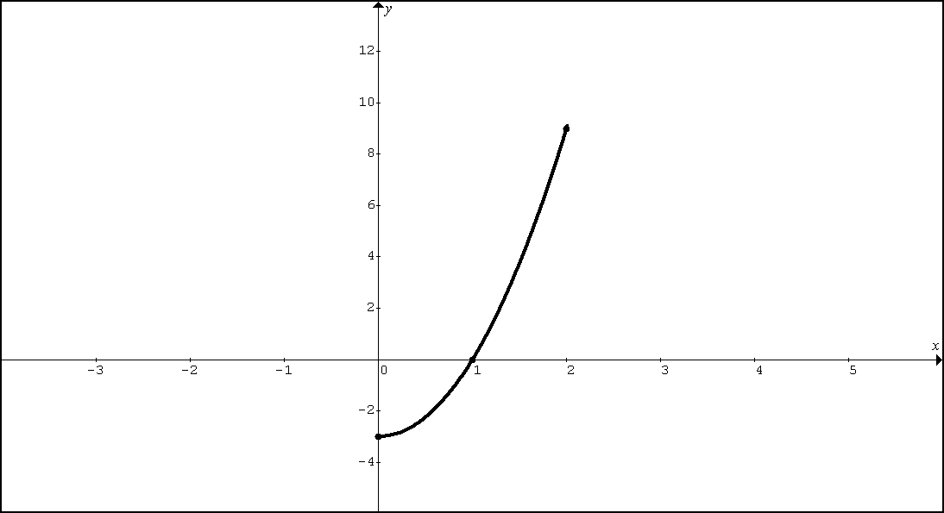

2. Find the area bounded by and the *x*-axis on the interval [-1, 2].

(a) BY HAND (b) BY TI89

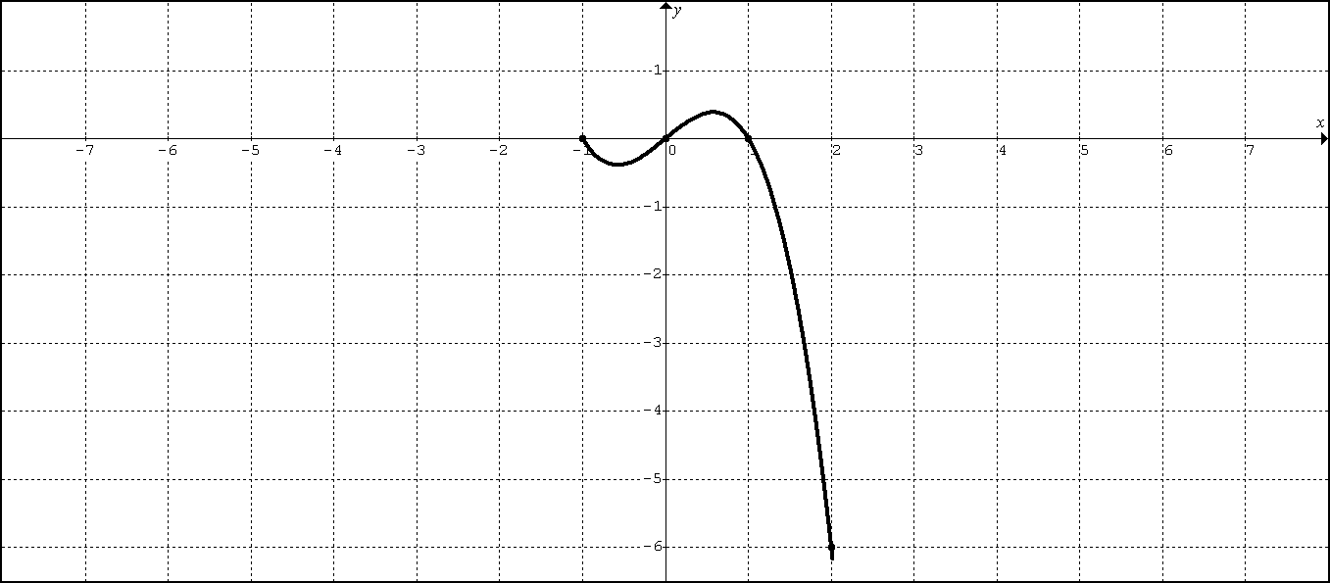 III. [**FTC2-AVERAGE VALUE**]:

1. (No Calculator) Find the average value of  on [0, 2]

2. (No Calculator) Find the average value of  on [-1, 2]

IV. [**FTC2-UB**]: (No Calculator)

Rewrite and evaluate each integral using the appropriate u-substitution and u-bounds.

1. 

2. 

V. [**FTC2–ID**]: (Technology Required) Fundamental Theorem of Calculus “in disguise”

1. Suppose and . Find .

2. Suppose and . Find .

BC Q301 CH5A LESSON 1B HW:

FTC2 INTEGRAL– BY HAND:

Section 5.3: 21, 23, 25, 27

Section 5.4: 27, 29, 31, 33, 35, 37

FTC2 INTEGRAL– BY TI89:

Section 5.4: 49, 50

FTC2 AREA– BY TI89:

Section 5.4: 41, 43, 45, 47

(APPEAL TO GEOMETRY) AVERAGE VALUE – BY HAND:

Section 5.3: 15, 16

FTC2 AVERAGE VALUE – BY HAND:

Section 5.3: 32, 34, 35

FTC2 AVERAGE VALUE – BY TI89:

Section 5.3: 11, 13

FTC2-UB

1. Rewrite and evaluate using an appropriate u-substitution and u-bounds.

2. Rewrite and evaluate  using an appropriate u-substitution and u-bounds.

FTC2-ID

1. Suppose and . Find 

2. Suppose and . Find 

**BC.Q301: LESSON 2 – FTC2: Fundamental Theorem of Calculus (Part II)  
Lesson 2A: APPLICATIONS**

A. Area Connection (Lesson 1-A)

B. Evaluation Method [FTC2] (Lesson 1-B)

C. FTC2 APPLICATIONS

C1: **Displacement/Position/Total Distance (Lesson 2A)**

**C1: Displacement/Position/Total Distance (Lesson 2A)**

A particle moves along the *x*-axis such that its position at time *t* is given as *x*(*t*).

The velocity of the particle at time *t* is given as .



**Review:**

* The particle is moving to the right when



* Acceleration is positive when



* The particle is getting faster (speed increasing) when and share the same sign.



**New:**

**LESSON 2A NOTES**

1. An object moves along the *x*-axis with initial position . The velocity of the object at time is given by .



A. What is the total distance traveled by the object over the time period ?



B. What is the position of the object at time *t* = 4?

C. What is the average velocity over the time period ?



D. What is the average acceleration over the time period ?



**LESSON 2A NOTES**

2. A particle moves along the *x*-axis so that its velocity at time *t* is given as .



At time *t* = 0, the particle is at position *x* = 1.

A. What is the total distance traveled by the particle from time t = 0 until time t = 3?

B. What is the position of the particle at time *t* = 3?

C. What is the average velocity from time *t* = 0 until time *t* = 3?

D. What is the average acceleration from time *t* = 0 until time *t* = 3?

**LESSON 2A NOTES**

3. AP:2000#2

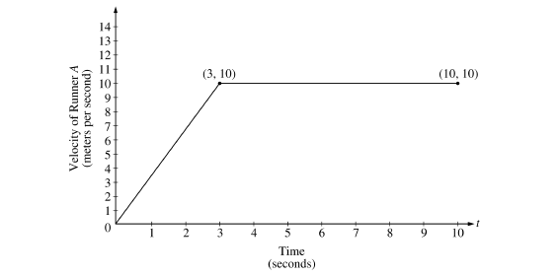

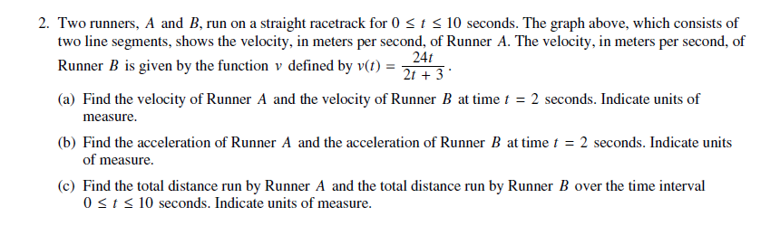

**LESSON 2A HW**

1. A particle moves along the y-axis so that its velocity v at time is given by . At time *t* = 0, the particle is at .



A. Find the total distance traveled by the particle between time *t* = 0 and time *t* = 2.

B. What is the position of the particle at time *t* = 2?

C. What is the average velocity over the time period ?



D. What is the average acceleration over the time period ?



**LESSON 2A HW**

2. AP:2011#1

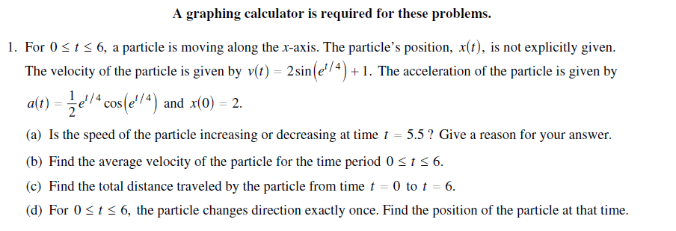

**LESSON 2A HW**

3. AP:2009#1

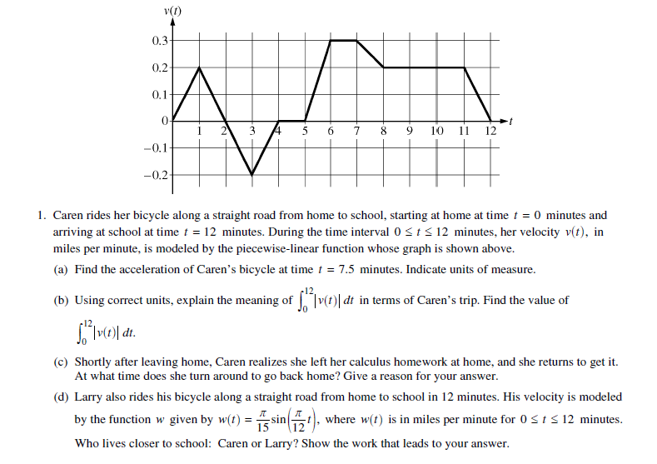

**LESSON 2B APPLICATIONS**

**C2: Accumulating Quantity/(Rate In – Rate Out) LESSON 2B NOTES**

1. The rate at which people enter an amusement park on a given day is modeled by the function *E* defined by .



The rate at which people leave the same amusement park on the same day is modeled by the function *L* defined by .



Both *E*(*t*) and *L*(*t*) are measured in people per hour and time *t* is measured in hours after midnight. These functions are valid for , the hours in which the park is open.



At time *t* = 9, there are no people in the park.

A. How many people have entered the park by 5:00 pm (*t* = 17)? Round to the nearest whole number.

B. The price of admissions to the park is $15 until 5:00 pm. After 5:00 pm the price of admissions to the park is $11. How many dollars are collected in admissions to the park on the given day? Round to the nearest whole number.

C. Let *H*(*t*) be the number of people in the park at time *t*. Find *H*(17).

D. Write a function, involving an integral expression, for *H*(*t*), the number of people in the park at time *t*.

**LESSON 2B NOTES**

2. Traffic flow is defined as the rate at which cars pass through an intersection, measured in cars per minute. The traffic flow at a particular intersection is modeled by the function *F* defined by for , where *F*(t) is measured in cars per minute and *t* is measured in minutes.



A. To the nearest whole number, how many cars pass through the intersection over the 30-minutes period?

B. What is the average traffic flow over the time interval ? Indicate units of measure.



C. What is the average rate of change of the traffic flow over the time interval ? Indicate units of measure.



**LESSON 2B NOTES**

3. AP:2010#3

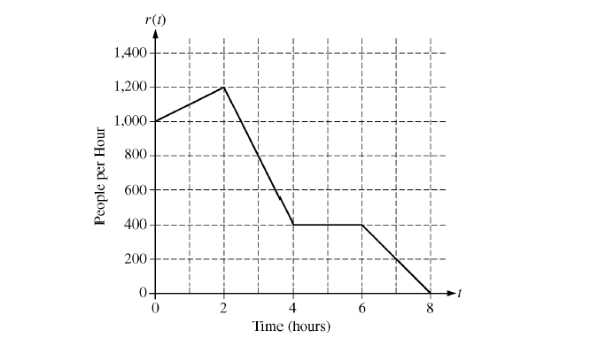

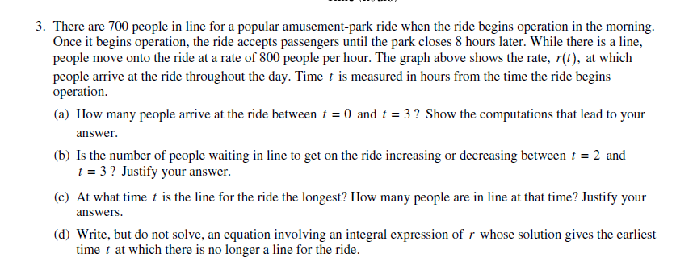**LESSON 2B HW**

1. The tide removes sand from Sandy Point Beach at a rate modeled by the function *R*, given by .



A pumping station adds sand to the beach at a rate modeled by the function *S*, given by .



Both *R*(*t*) and *S*(*t*) have units of cubic yards per hour and *t* is measures in hours for . At time *t* = 0, the beach contains 2500 cubic yards of sand.



A. How much of the sand will the tide remove from the beach during this 6-hour period? Indicate units of measure.

B. Write a function, involving an expression, for *Y*(*t*), the total number of cubic yards of sand on the beach at time *t*.

C. Find the rate at which the total amount of sand on the beach is changing at time *t* = 4.

D. Find the total number of cubic yards of sand on the bank at time *t* = 4.

**LESSON 2B HW**

2. AP:2003FB#2

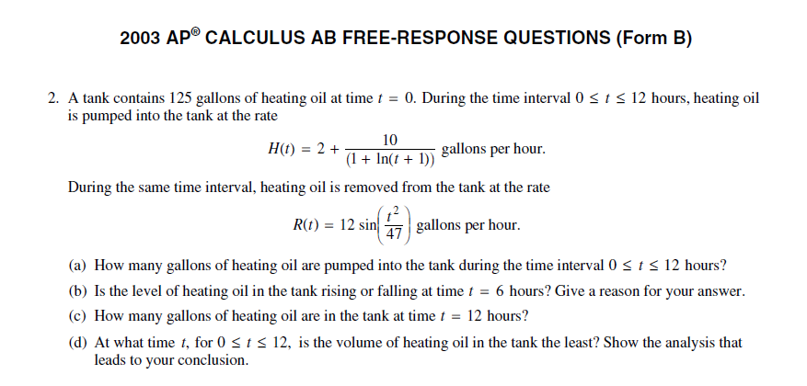

**LESSON 2B HW**

3. AP:2002FB#2

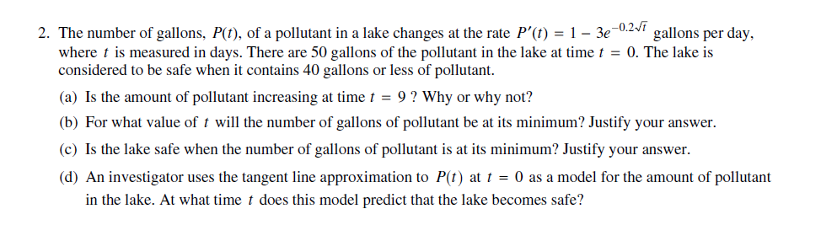

**LESSON 2B HW**

4. AP:2010#1

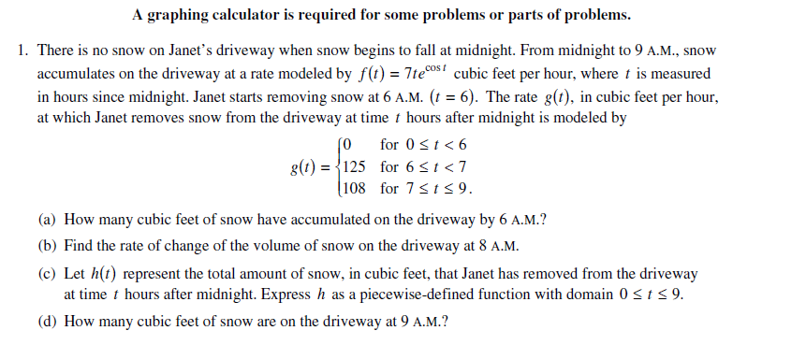

**BC: Q301: LESSON 3 – WARM UP**

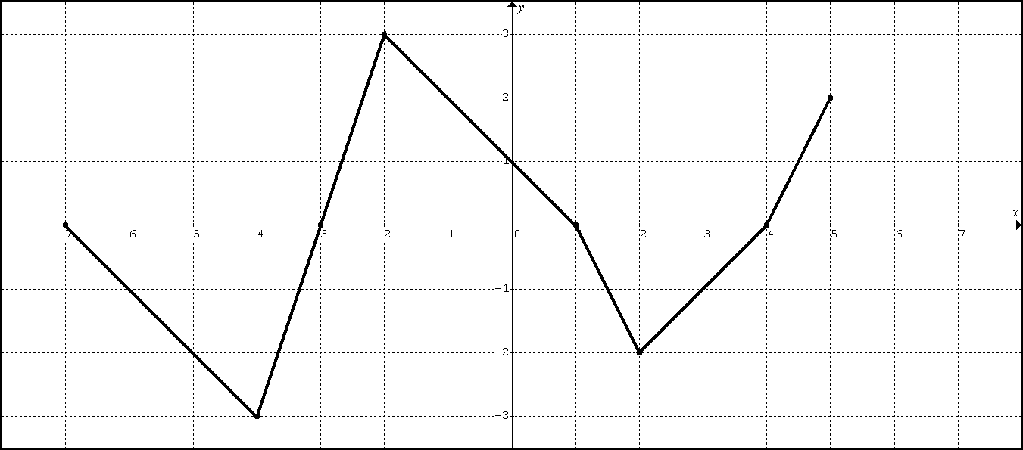

The graph above represents  (the derivative of the function) on .

Suppose .

1. Evaluate 

2. Find and 

3. What is the average rate of change in on the interval ?



The graph above represents  (the derivative of the function) on 

Suppose .

4. Find , , , and 

5. For what value(s) of *x* will the function  have a local minimum? Justify.

6. For what value(s) of *x* will the function  be concave downward? Justify.

**LESSON 3A:** GUIDED PRACTICE 1: 2007FB #4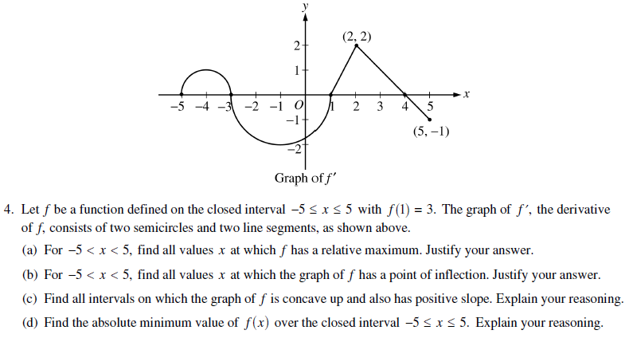**LESSON 3A:** PRACTICE 2: 2008FB#5

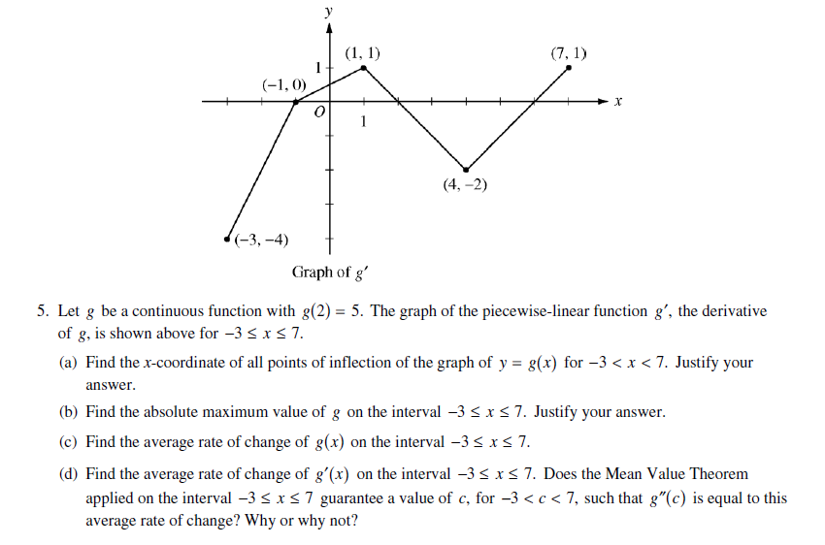

**LESSON 3A:** PRACTICE 3: 2015 #5

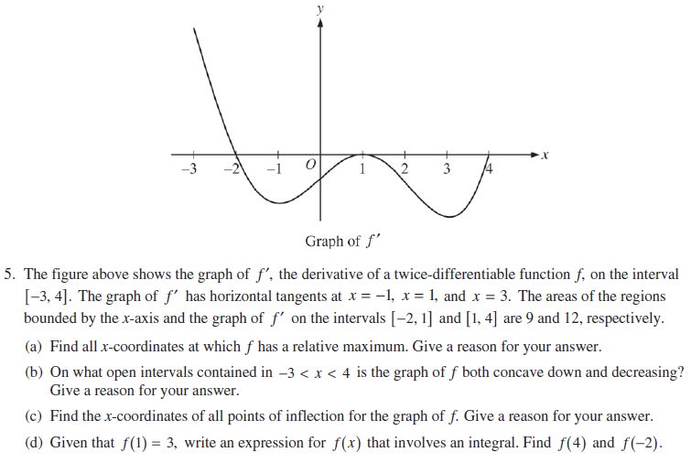

**LESSON 3A:** PRACTICE 4: 2003 #4

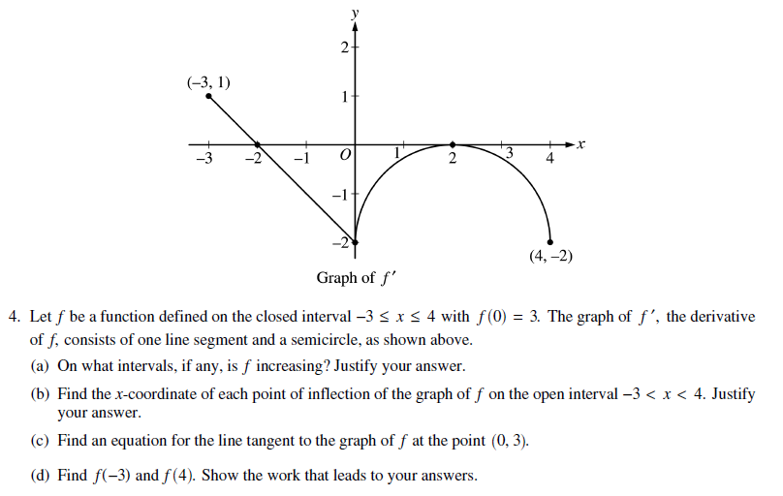

**LESSON 3B:** THE FUNDAMENTAL THEOREM OF CALCULUS PART 1

Defining the relationship: 

Defining the relationship:  (*a* is a constant)

**LESSON 3B:** GUIDED PRACTICE 1: 1999 #5 (adaptation)

(1, 4)

(4, -1)

(2, 1)

-2

2

2

-2

EX1: The graph of the function *f*, consisting of three line segments, is given above. Let 

A. Compute *g*(4) and *g*(-2)

B. Find the instantaneous rate of change of *g*, with respect to *x*, at *x* = 1.

C. Find the absolute maximum and minimum values of *g* on the closed interval [-2, 4]. Justify your answer.

D. The second derivative of *g* is not defined at *x* = 1 and *x* = 2. How many of these values are *x*-coordinates of points of inflection of the graph of *g*? Justify your answer.

**LESSON 3B:** PRACTICE 2: 2012 #3

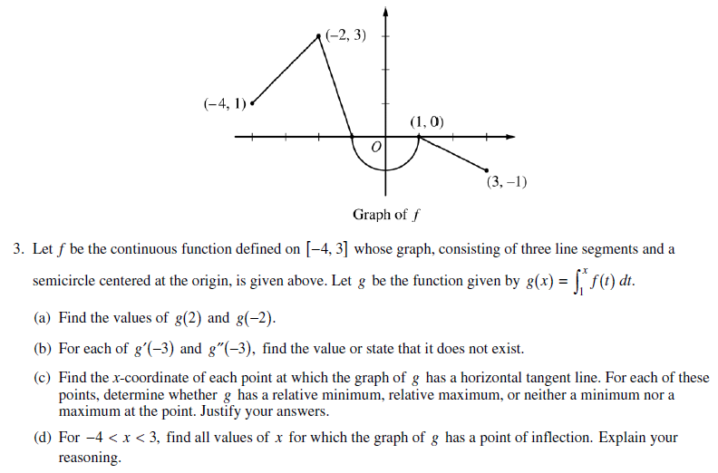

**LESSON 3B:** PRACTICE 3: 2014 #3

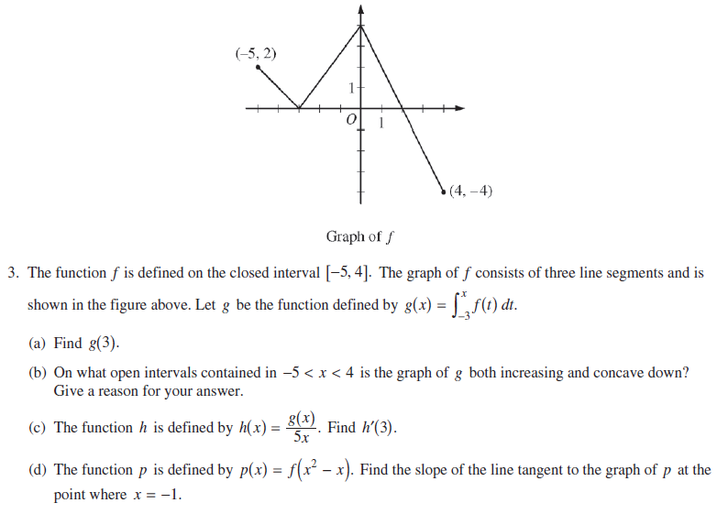

**LESSON 3B:** PRACTICE 4: 2011 #4

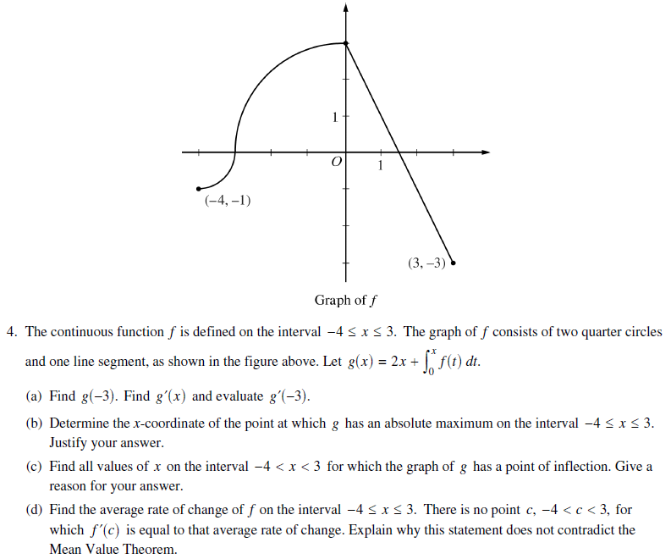

**LESSON 3B:** ADDITIONAL PRACTICE 1: 2004 #5

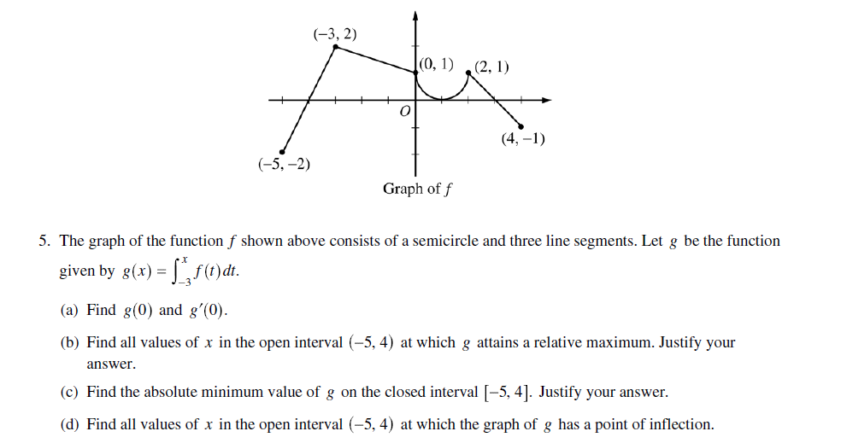

**LESSON 3B:** ADDITIONAL PRACTICE 2: *VERY CHALLENGING* 2005FB #5

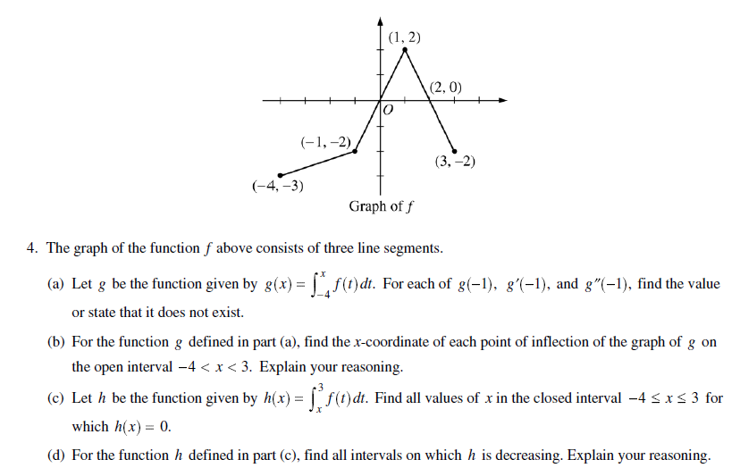

**BC: Q301: LESSON 4 – APPROXIMATING A DEFINATE INTEGRAL**

**Approximating a Definite Integral with a Riemann Sum**

RECTANGLE APPROXIMATION

 where is the value of *f* at *x* = *c* on the *k*th interval.

TRAPEZOIDAL APPROXIMATION

 where  and is constant.

1. Consider the area under the curve (bounded by the *x*-axis) of  from  to .

Use 4 equal rectangles whose heights are the left endpoint of each rectangle to approximate the area. (LRAM)

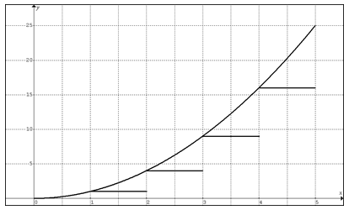

Use 4 equal rectangles whose heights are the right endpoint of each rectangle to approximate the area. (RRAM)

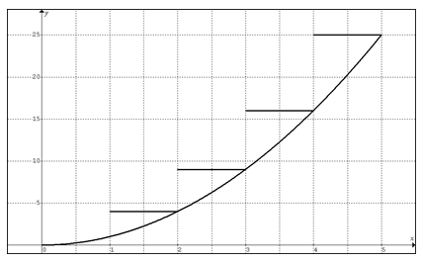

Use 4 equal rectangles whose heights are the midpoint of each rectangle to approximate the area. (MRAM)

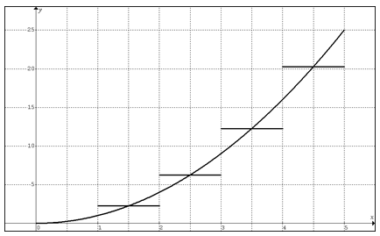

Use 4 trapezoids of equal width to approximate the area. (TRAM)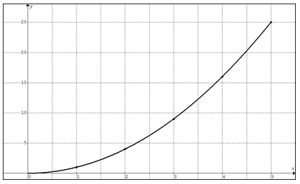

2. Use LRAM, MRAM, and TRAM with *n* = 3 equal rectangles to estimate the where values of the function are as given in the table below.

|  |  |  |  |  |  |  |  |
| --- | --- | --- | --- | --- | --- | --- | --- |
| *x* | 2.0 | 2.25 | 2.5 | 2.75 | 3 | 3.25 | 3.5 |
| *y* | 3.2 | 2.7 | 4.1 | 3.8 | 3.5 | 4.6 | 5.2 |

3. Use a Trapezoidal approximation with *n* = 3 trapezoids to estimate the where values of the function are as given in the table below.

|  |  |  |  |  |
| --- | --- | --- | --- | --- |
| *x* | 2.0 | 3 | 5 | 5.5 |
| *y* | 3.2 | 2.7 | 4.1 | 3.8 |

4.

|  |  |
| --- | --- |
| *t* (hours) | *R*(*t*) (gallons per hours) |
| 0 | 9.6 |
| 3 | 10.4 |
| 6 | 10.8 |
| 9 | 11.2 |
| 12 | 11.4 |
| 15 | 11.3 |
| 18 | 10.7 |
| 21 | 10.2 |
| 24 | 9.6 |

The rate at which water flows out of a pipe, in gallons per hour, is given by a differentiable function *R* of time *t*. The table above measured every 3 hours for a 24-hour period.

A. Using correct units, explain the meaning of the integral in terms of water flow.

B. Use a trapezoidal approximation with 4 subdivisions of equal length to approximate .

C. Use a midpoint Riemann sum with 4 subdivisions of equal length to approximate the average of *R*(*t*).

D. The rate of water flow *R*(*t*) can be approximated by . Use *Q*(*t*) to approximate the average rate of water flow during the first 24-hour time period. Indicate the units of measure.

HW1: 1998 #3

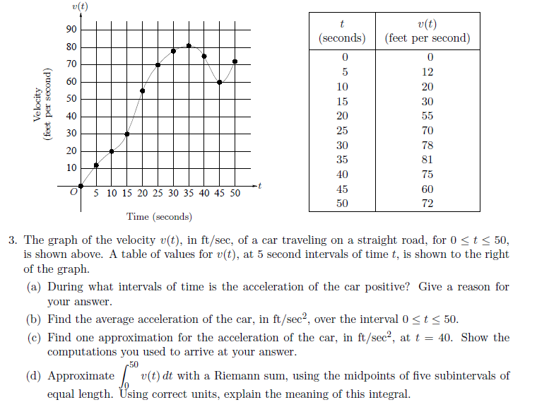

HW2: 2004FB #3

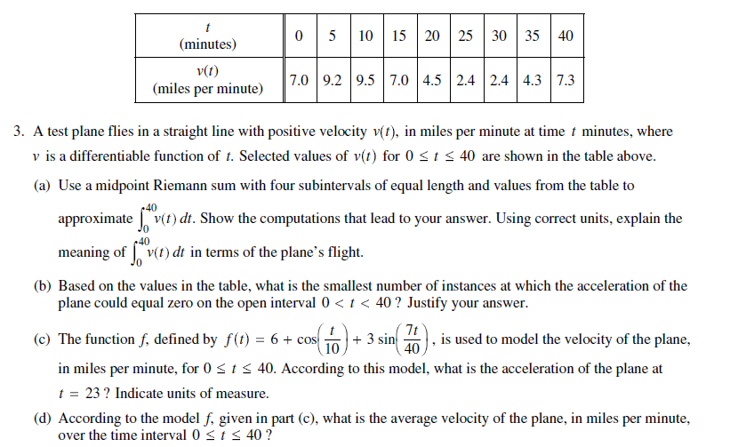HW3: 2008 #2

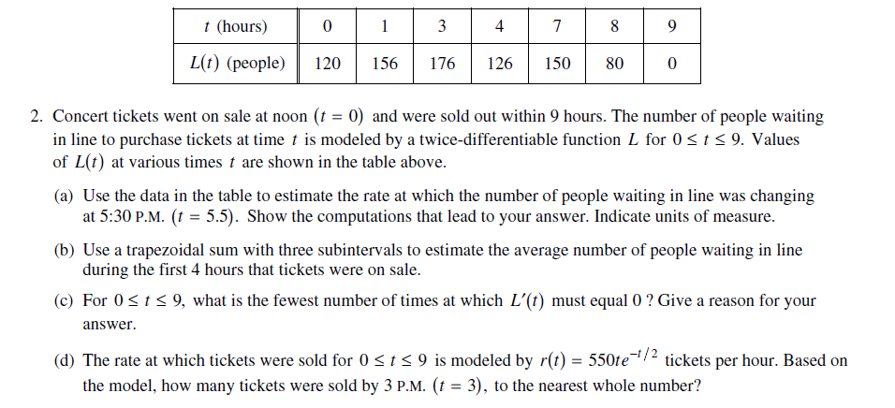

**BC: Q301 LESSON 5: FTC-1 and THE CHAIN RULE**

**LESSON 5: BASIC PRACTICE** Find for each equation below.

1. 

2. 

3. 

4. 

**BC: Q301 LESSON 5 REVIEW PRACTICE EXERCISE**

|  |  |  |  |  |  |  |
| --- | --- | --- | --- | --- | --- | --- |
|  | -2 | 0 | 1 | 5 | 7 | 8 |
|  | 14 | 5 | 2 | -3 | -10 | 9 |

Let  where is a differentiable function with specific values as shown above.

1. Estimate using a trapezoidal approximation with four trapezoids.

2. Find 

3. Estimate 

4. If , estimate  using a left Riemann sum with three rectangles.

5. If , find .

6. If , find .

**BC. Q301 LESSON5 (MVT REVIEW PRACTICE) – CALCULATORS REQUIRED**

Let  on .

1. Find the average rate of change in *f* on [-1, 4.5].

2. Find the value(s) of *x* that satisfy the conclusion to the Mean Value Theorem for derivatives.

3. Find the average value of *f* on [-1, 4.5].

4. Find the value(s) of *x* that satisfy the conclusion to the Mean Value Theorem for integrals.