BC.Q104.NOTES: Chapter 3.8, 3.9 – Lesson 1

Quick Reference
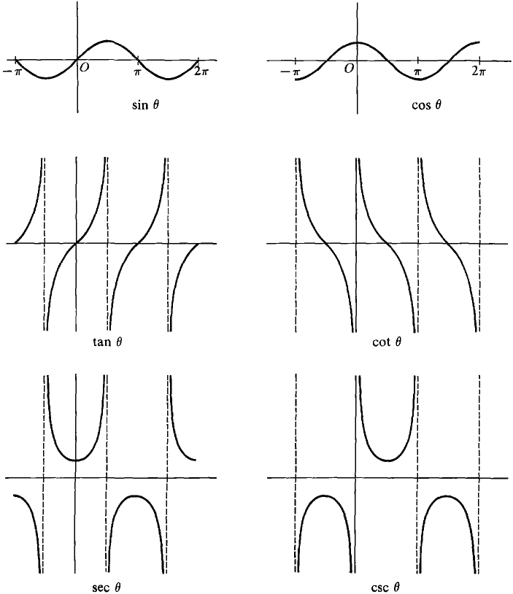

$$y=\text{sin}(x)$$  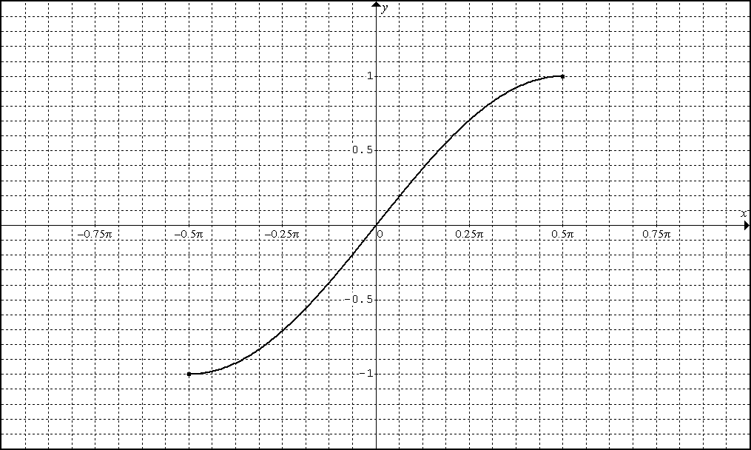 | $$y={\text{sin}}^{−1}(x)$$  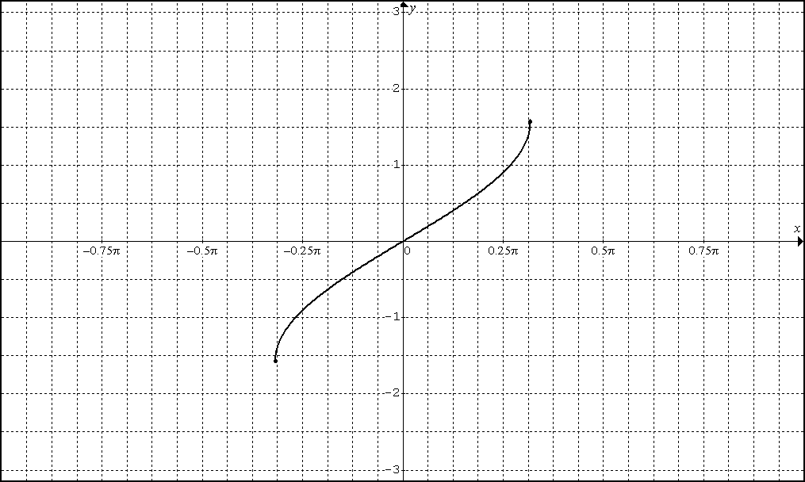
$$y=\text{tan}(x)$$  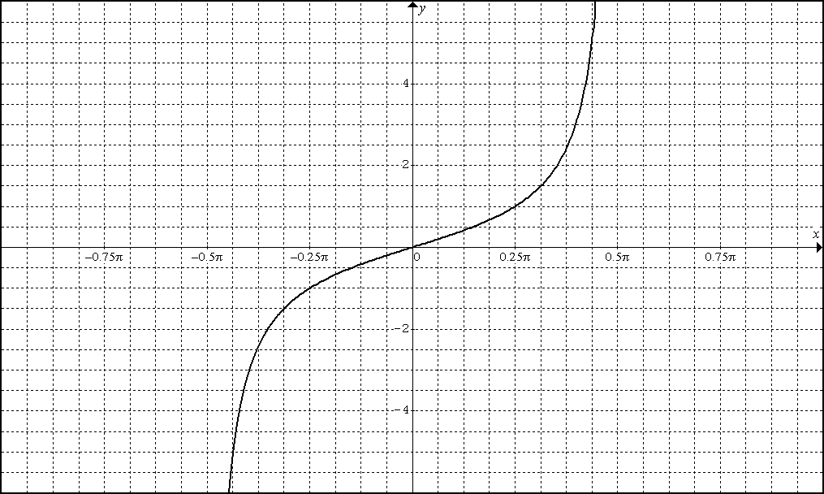 | $$y={\text{tan}}^{−1}(x)$$  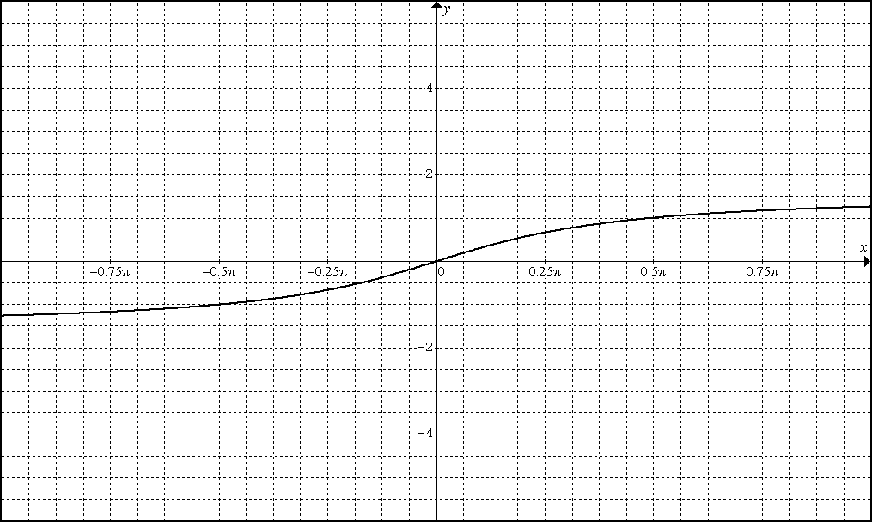
$$y=\text{sec}(x)$$  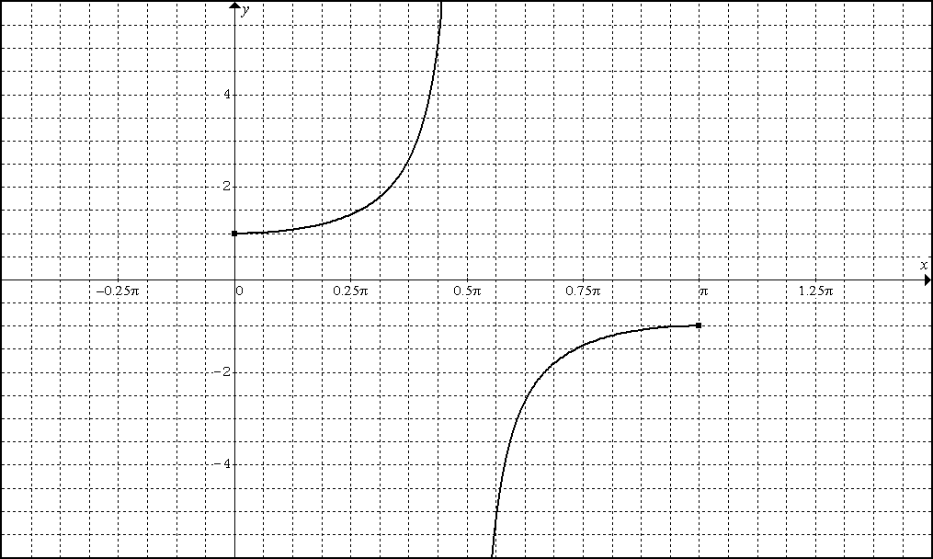 | $$y={\text{sec}}^{−1}(x)$$  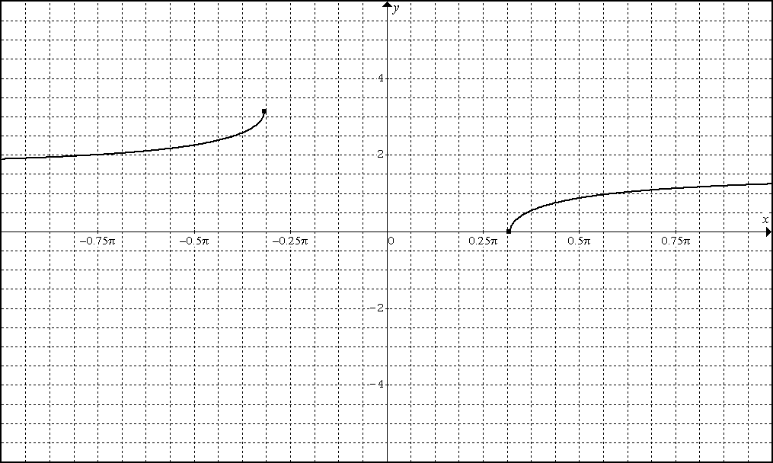

Development of Inverse Trigonometric Function Derivatives
Development of Transcendental Function Derivatives
Practice Problems

Practice Problems Continued

LESSON 1 HW

Section 3.8: #1 – 21 odd, 35-40 M.C.

Section 3.9: #5-25 odd, 31, 49

(LEAVE THE ANSWERS UNSIMPLIFIED)
SECTION 3.8 | SECTION 3.9
1. Find  3. Find  5. Find  7. Find  9. Find  11. Find  13. Find  15. Find  17. Find  19. Find  21.  Find | 5. Find  7. Find  9. Find  11. Find  13. Find  15. Find  17. Find  19. Find  21. Find  23. Find  25. Find

3.9 #31
A line with slope m passes through the origin and is tangent to .
What is the value of m?

3.9 #49
Find an equation for the line tangent to the graph of and goes through the origin.

3.8 #35-40 Multiple Choice
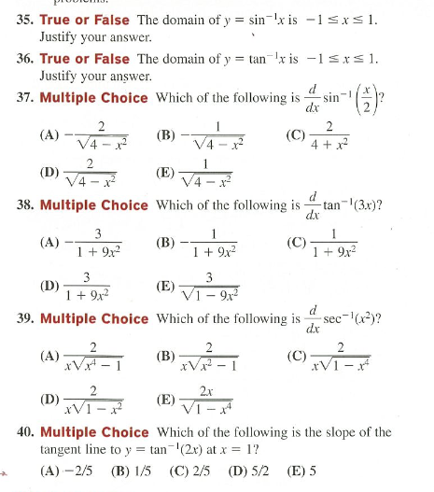

1. IN Section 3.8 #5 This answer simplifies to .
SHOW HOW.
LESSON 1 HW EXTENSION

2. IN Section 3.8 #17 This answer simplifies to .
SHOW HOW.

3. IN Section 3.8 #37 This answer simplifies to .
SHOW HOW.
BC.Q104.NOTES: Chapter 3.8, 3.9 – Lesson 2

PART I. Derivatives with Log Properties and Logarithmic Differentiation

First Using Log Properties to Find a Derivative

Logarithmic Differentiation

Part II. Calculus of General Inverses Functions

THM: If the domain of a function f is an interval on which
or on which , then the inverse of f is also a function.

implies that f is increasing.
implies that f is decreasing.

FORMULA:

Example: Consider on ).

1. Prove that the inverse of is also a function?

2. Find the slope of the inverse function at

EXAMPLE 2: is a one-to-one function.

EXAMPLE 3: is a one-to-one function.

EXAMPLE 4: is a one-to-one function. Let

Formula Development

Task: Construct a relationship between the slope of a function f at (a, b) and the slope of the inverse function at (b, a).

LESSON 2 HW

Section 3.9 #43, 45, 46, and 47 + MC 2 and 3
Section 3.8 #28, 29 + extra problem
3.9 #43: . Find using logarithmic differentiation.
3.9 #45: . Find using logarithmic differentiation.

3.9 #45: . Find using logarithmic differentiation.
3.9 #47: . Find using logarithmic differentiation.
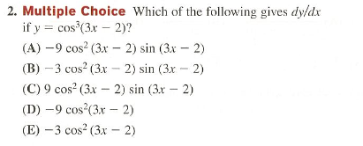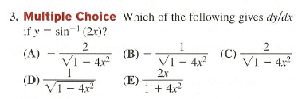
3.8 #28: Let
(A) Prove that the inverse of f is also a function
(B) Find and
(C) Find and

3.8 #29: Let . Also let
(A) Prove that the inverse of f is also a function
(B) Find

EXTRA PROBLEM: Find a positive value of such that the tangent to at also passes through the point (0,2).

