Q103.BC.Notes: Chapter 3.7, 4.6, 4.5

LESSON 1 – 3.7 Implicit Differentiation

INTRODUCTION:

Identify the Shape: $x^{2}+y^{2}=1$, $9x^{2}+4y^{2}=\text{40}$, $2x^{2}−y^{2}=3$, $y^{4}+3y−4x^{3}=5x+1$

What does $\frac{\text{dy}}{\text{dx}}$represent in reference to the equations above?

Example 1: $y^{4}+3y−4x^{3}=5x+1$

A. Find $\frac{\text{dy}}{\text{dx}}\text{.}$

B. Find the slope of the tangent line at the point P(1, -2)

C. Use implicit differentiation to find $\frac{d^{2}y}{{\text{dx}}^{2}}\text{.}$
2. Find $\frac{\text{dy}}{\text{dx}}$and $\frac{d^{2}y}{{\text{dx}}^{2}}$if $x^{2}+y^{2}=1$

3. Find $\frac{\text{dy}}{\text{dx}}$ if $4{\text{xy}}^{3}−x^{2}y+x^{3}−5x+6=0$

4. Find $\frac{\text{dy}}{\text{dx}}$ if $y=x^{2}\text{sin}y$
5. Find $\frac{\text{dy}}{\text{dx}}$ if $\text{tan}(\text{xy})+x^{2}y+2=x$ .
Find an equation of the line tangent to the curve at the point when $y=0$.

AP Question

Consider the curve given by${\text{xy}}^{2}−x^{3}y=6$.

- Show that $\frac{\text{dy}}{\text{dx}}=\frac{3x^{2}y−y^{2}}{2\text{xy}−x^{3}}$
- Find all the points on the curve whose x-coordinate is 1, and write an equation for the tangent line at each of these points.
- Find the x-coordinate of each point on the curve where the tangent line is vertical.

LESSON 1 HW:
AP QUESTION ON PREVIOUS PAGE + SECTION 3.7: # 1, 5, 17, 21, 49, 56, 57

(Section 3.7)
#1: Let Find .

#5: Let Find .

#17: Let
Find an equation of both the tangent and normal lines to the curve at the point (2, 3).

#21: Let
Find an equation of both the tangent and normal lines to the curve at the point (-1, 0).

#29: Let Find and then .

#49: Find the two points where the curve crosses the x-axis, and show that the tangents to the curve at these points are parallel. What is the common slope of these tangents?

#56: The line that is normal to the curve at (1, 1) intersects the curve at what other point?

#57 Find the normals to the curve that are parallel to the line

Lesson 2 - Chapter 4.6 Related Rates

Ex: 1 A ladder 20 ft long leans against the wall of a vertical building. If the ladder slides away from the building horizontally at a rate 2 ft/sec, how fast is the ladder sliding down the building when the top of the ladder is 12 ft above the ground?

Ex: 2 A camera is mounted at a point 3000 ft from the base of a rocket launching pad. If the rocket is rising vertically at 880 ft/s when it is 4000 ft above the launching pad, how fast must the camera elevation angle change at that instant to keep the camera aimed at the rocket?
Ex: 3 A water tank has the shape of an inverted right circular cone of altitude 12 ft and base 6 ft. If water is being pumped into the tank at a rate of 1.2${\text{ft}}^{3}$/min, approximate the rate at which the water level is rising when the water is 3 ft deep.

EX 4: A urinal is 15 ft long and 4 ft across the top. Its ends are isosceles triangles with height 3 ft. Pee runs into the urinal at the rate of 2.5 ft³/min. How fast is the pee rising when it is 2 ft deep?

W
W
θ
K
K
ball
goal

EX 5: Walter approaches the soccer ball, due south, at a rate of 12 ft/s as Kevin approaches the soccer goal, due east, at 10 ft/s. When Walter is 6 ft from the ball and Kevin is 8 ft from the ball …

- What is the change in rate of the distance between the two boys?

(b) What is the change in rate of angle $θ$?
LESSON 2 HW:
SECTION 4.6 #11, 21, 29, 34, 17 EXTRAS: 4.6 # 14, 16, 19, 25

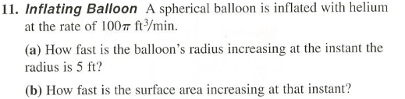
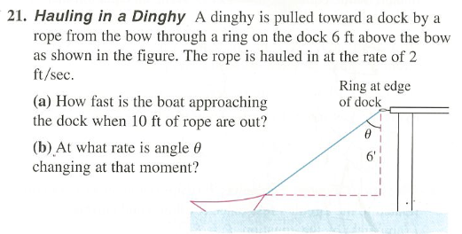
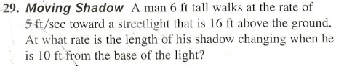
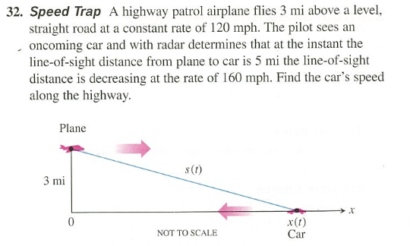
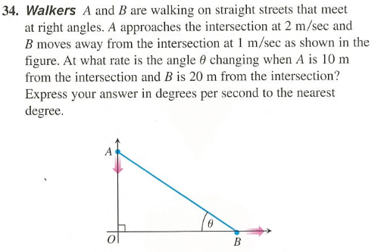
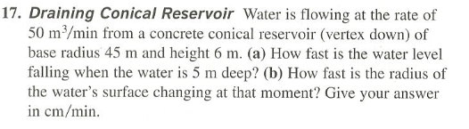
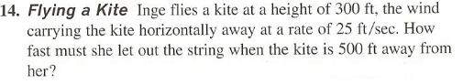
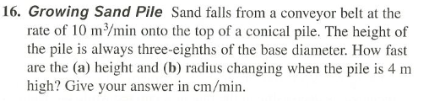
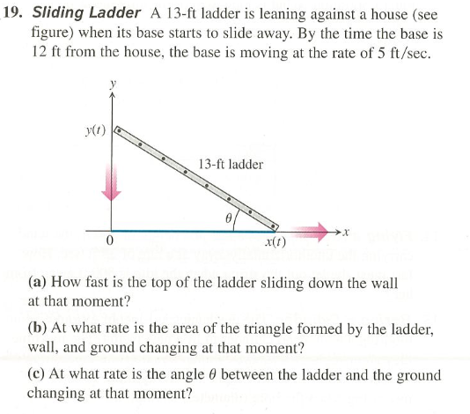
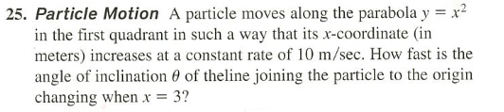
Lesson 3 – Chapter 4.5 Notes (Linear Approximation)

GRAPHICAL REPRESENTATION

1. Find the linearization of (line tangent to) $f(x)=2x^{2}−3x$ at $x=2$.

2. Use the linearization (tangent line) to approximate$f(2\text{.}5)$.

3. Estimate the change in $f(x)=3x−x^{4}$when x increases from 1 to 1.05.
Lesson 3 – Practice

1. Let $f(x)=\sqrt{x^{2}+9}$.
Use a linearization of f at $x=−4$and use it to approximate $f(−3\text{.}9)$.

2. Let $f(x)=\text{ln}(x+1)$.
Use a linearization of f at $x=0$and use it to approximate $f(0\text{.}2)$.

3. Let f be a function with $f(0)=2$ and $f^{}(x)=e^{x}\text{cos}(x)$.
Use a linearization of f at $x=0$and use it to approximate $f(0\text{.}5)$

4. Let f be a function with $f(0)=\text{10}\text{.}2$ and $f^{}(x)=2\text{sin}\left(\frac{π}{2}−x\right)$.
Use a linearization of f at $x=0$and use it to approximate $f(−0\text{.}3)$

5. Use a linearization to estimate

6. Estimate the change in $f(x)=x^{3}+2x$when x increases from 1 to 1.03.

7. Estimate the change in volume of a sphere if the radius goes from 10 to 10.05 cm.

8. Estimate the change in area of a circle if the radius goes from 5 to 5.2 mm.

Lesson 3 (SECTION 4.5) – Homework

1. Let $f(x)=2+\text{sin}x$.
Use a linearization of f at $x=0$and use it to approximate $f(−0\text{.}1)$.

2. Let $f(x)=x^{3}−2x+3$.
Use a linearization of f at $x=2$and use it to approximate $f(1\text{.}8)$.

3. Let f be a function with $f(3)=7$ and $f^{}(x)=\sqrt{1+x}$.
Use a linearization of f at $x=3$and use it to approximate $f(2\text{.}5)$.

4. Let f be a function with $f(0)=4$ and $f^{}(x)=\text{cos}(x^{2})$.
Use a linearization of f at $x=0$and use it to approximate $f(0\text{.}4)$.

5. Let f be a function with $f(4)=3$ and $f^{}(x)=2−x$.
Use a linearization of f at $x=4$and use it to approximate $f(4\text{.}2)$.

6. Estimate the change in $f(x)=x^{2}−5x$ as x increase from 2 to 2.1

7. Estimate the change in volume of a cube if edge decreases from 9 to 8.99 mm.

8. Estimate the change in circumference of a circle if the diameter changes from 2 to 2.02 in.

9. Use a linearization to approximate .

10. AP Related Rates Problems: 1987 AB5 and 1990 AB4

11. EXTRA related rates problems from Lesson 2 HW
