Q101.BC.NOTES: Chapter 2.3, 2.4, 3.1, 3.2

Define $\sqrt{x^{2}}$: Definition of $\left|x\right|$:

PART 1: IS f CONTINUOUS AT x = a?

Definition of a function continuous at x = a:

Theorem:

1. Let $f(x)=\begin{aligned}\left\{5−2x; x≥1 | \right.\end{aligned}$ Prove that f is or is not continuous at $x=1\text{.}$ Support graphically.

2. Let $g(x)=\begin{aligned}\left\{\frac{|x−2|}{x−2}; x≠2 | \right.\end{aligned}$. Prove that g is or is not continuous at $x=2\text{.}$Support graphically.

3. Let $p(x)=\begin{aligned}\left\{\frac{x^{2}−1}{x+1}; x≠−1 | \right.\end{aligned}$. Prove that p is or is not continuous at $x=−1$.
PART 2: DERIVATIVE DEFINITION

DERIVATIVE INTRODUCTION
DEFINITION DEVELOPMENT

Average rate of change of f on [a,b]
Slope of the secant line though curve f on [a, b]

Standard:

Alternate:

Instantaneous rate of change of f at $x=a$
Slope of the line tangent to the curve of f at $x=a$
Derivative of f at $x=a$

Standard:

Alternate:

1. Consider the function $y=f(x)$where$f(x)=3x^{2}−2$
a. Find the average rate of change in f on the interval [-1, 2]

b. Using the standard definition of a derivative at $x=a$ …
Find the instantaneous rate of change in f at $x=1\text{.}$ (Precede your answer with Lagrange notation).

c. Write an equation of the tangent line to the graph of $f(x)$at $x=1\text{.}$

2. Consider the function $y=f(x)$where$f(x)=\sqrt{x+1}$
a. Find the average rate of change in f on the interval [0, 8]

b. Using the alternate definition of a derivative at $x=a$ …
Find the instantaneous rate of change in f at $x=3\text{.}$ (Precede your answer with Lagrange notation).

c. Write an equation of the tangent line to the graph of $f(x)$at $x=3$.

3. Consider the function $y=f(x)$where$f(x)=\begin{aligned}\left\{5−2x; x≥1 | \right.\end{aligned}$
a. Find the average rate of change in f on the interval [0, 2]

b. Using the standard definition of a derivative at $x=a$ …
Find the instantaneous rate of change in f at $x=1\text{.}$ (Precede your answer with Lagrange notation).

c. Write an equation of the tangent line to the graph of $f(x)$at $x=1$.

4. Consider the function $y=g(x)$where$g(x)=\begin{aligned}\left\{5−x; x≥0 | \right.\end{aligned}$
a. Find the average rate of change in g on the interval [-2, 5]

b. Using the standard definition of a derivative at $x=a$ …
Find the instantaneous rate of change in g at $x=0\text{.}$ (Precede your answer with Lagrange notation).

c. Write an equation of the tangent line to the graph of $g(x)$at $x=1$.

LESSON 1 – HW:

1. Prove that $f(x)=x^{2}−2x+3$is or is not continuous at $x=1$.

2. Prove that $g(x)=\begin{aligned}\left\{2+\sqrt{x}; x>0 | \right.\end{aligned}$ is or is not continuous at $x=0$.

3. Prove that $r(x)=\begin{aligned}\left\{x+2; x≠−1 | \right.\end{aligned}$is or is not continuous at $x=−1$.

4. Prove that $f(x)=\begin{aligned}\left\{x^{2}+2; x≥0 | \right.\end{aligned}$ is or is not continuous at $x=0$.

5. A. Prove that $g(x)=\frac{x^{2}−9}{x−3}$is not continuous at $x=3$.
B. Extend g(x), making it a piecewise function that is continuous at$x=3$.

6. A. Prove that $d(x)=\frac{x−4}{\sqrt{x}−2}$is not continuous at $x=4$.
B. Extend d(x), making it a piecewise function that is continuous at$x=4$.

7. Prove that $h(x)=\left\{\begin{matrix}x\text{sin}\frac{1}{x} x≠0 \\ 0 x=0\end{matrix}\right.$ is or is not continuous at $x=0\text{.}$
Hint: See the Sandwich Theorem of Limits.

8. If $f(2)=3$and $f^{}(2)=5$, find an equation of (a) the tangent line, and (b) the normal line to the graph of $y=f(x)$at the point where $x=2$.

9. Consider the function $y=f(x)$where$f(x)=x^{2}−4x$
a. Find the average rate of change in f on the interval [-2, 4]
b. Find the slope of the tangent line to the graph of $f(x)$ at $x=1$, i.e. the derivative of f at x = 1.
c. Write an equation of the tangent line $ℓ$to the graph of $f(x)$at $x=1\text{.}$

10. Consider the function $y=f(x)$where$f(x)=\begin{aligned}\left\{−x; x<0 | \right.\end{aligned}$
a. Find the average rate of change in f on the interval [-2, 4]
b. Find the slope of the tangent line to the graph of $f(x)$ at $x=0$, i.e. the derivative of f at x = 0.

c. Write an equation of the tangent line $ℓ$to the graph of $f(x)$at $x=0\text{.}$

11. Consider the function $y=f(x)$where
a. Find the average rate of change in f on the interval [-4, 0]
b. Find the instantaneous rate of change in $f(x)$ at $x=−2$.
Classify $f(x)$as either smooth, a corner, a cusp, a vertical line tangent, or discontinuous at .
c. Write an equation of the tangent line to the graph of $f(x)$at $x=−2\text{.}$

12. Consider the function $g(x)=\frac{1}{x}$.
a. Find $g^{}(2)$using the standard definition of the derivative at x = a.
b. Find $g^{}(2)$using the alternate definition of the derivative at x = a.

BC: Q101 LESSON 2

Review Illustration (What does it mean for a function to be differentiable at x = a?)

PART 3: DERIVATIVE ESTIMATION
1. The function is shown below. This function consists of line segments (in gray) and other non-linear curves (in black). Integer coordinates have been highlighted.

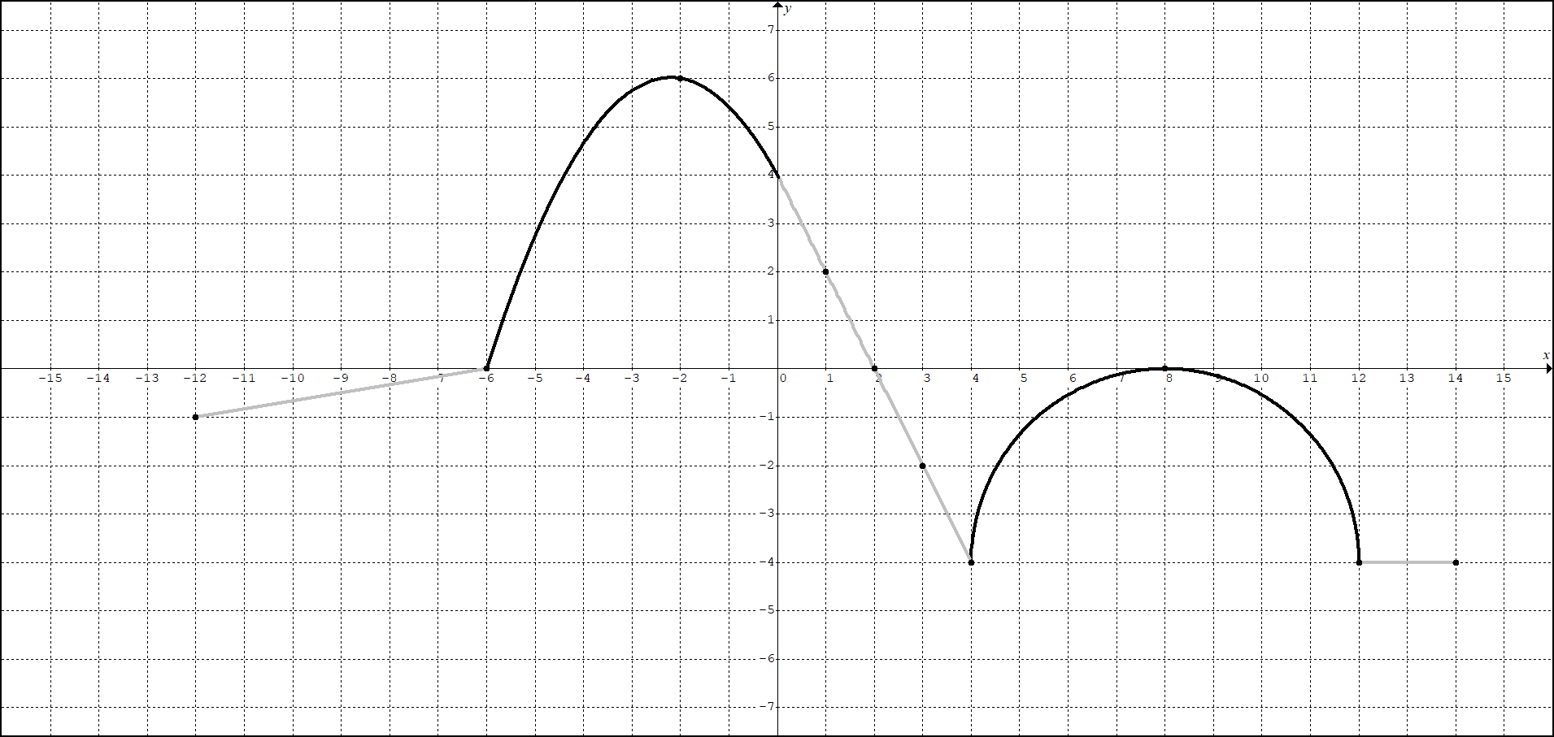
A) Find or estimate

B) Find or estimate

C) Find or estimate

D) Find or estimate

E) Find or estimate

F) Find or estimate

G) Find or estimate

H) Find or estimate

I) Find or estimate

J) Find or estimate all values of x where has a horizontal tangent.
2. Estimating the derivative with “an average on a small neighborhood.”
The coordinates of f for various values of x are given.
x | 0 | 0.5 | 1.0 | 1.5 | 2.0 | 2.5 | 3.0 | 3.5 | 4.0
f | -12 | -15 | -16 | -15 | -12 | -7 | 0 | 9 | 20

Assuming a smooth curve representation of $f(x)$.

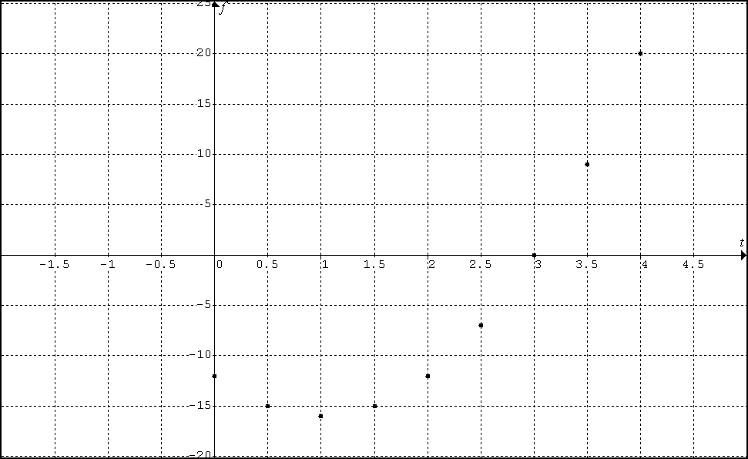

A) Eyeball estimate $f^{}(1)$

B) Eyeball estimate $f^{}(2\text{.}5)$

C) Use a standard estimation of $f^{}(1)$. Show your work.

D) Use a standard estimation of . Show your work.

PART 4: SPIRAL REVIW AND THE CONTINUITY AND DIFFERENTIBILITY CONNECTION
3. Consider the function $y=f(x)$where $f(x)=x^{2/3}$
a. Find the average rate of change in f on the interval [-1, 1]

b. Using the alternate definition of a derivative at $x=a$ …
Find the instantaneous rate of change in f at $x=0\text{.}$ (Precede your answer with Lagrange notation).

c. Write an equation of the tangent line to the graph of $f(x)$at $x=0$.
4. Consider the function
A. Use the standard definition of a derivative at to prove that p is or is not differentiable at . In other words, prove that the function p does or does not have a derivative at .
B. Classify the behavior of at .
C. Provide a formal proof for whether or not is continuous at .
LOGIC:

THM:

PROOF:

PART 5 DERIVATIVE FUNCTION

DEFINTION: The derivative of the function $f$with respect to the variable $x$is the function $f^{}$whose value at $x$ is $f^{}(x)={\text{lim}}_{h→0}\frac{f(x+h)−f(x)}{h}$, provided it exists.
(NO ALTERNATE DEFINITION)

DEF: Differentiable on an interval
A function is differentiable on an open interval (a, b) if $f^{}(x)$exists for every x in that interval.
A function is differentiable on a closed interval [a, b] if f is differentiable on the open interval (a, b) and if the following limits exist:
$f_{+}^{}(a)={\text{lim}}_{h→0^{+}}\frac{f(a+h)−f(a)}{h}$ and $f_{−}^{}(b)={\text{lim}}_{h→0^{−}}\frac{f(b+h)−f(b)}{h}$.

THM: Polynomial functions, unless restricted or broken, are differentiable for all values of x.

Definition: The derivative of the function $f$with respect to the variable $x$is the function $f^{}(x)$whose value at $x$ is $f^{}(x)={\text{lim}}_{h→0}\frac{f(x+h)−f(x)}{h}$, provided it exists.
NO ALTERNATE DEFINITION FOR $f^{}(x)$

1. Consider the function$f(x)=3x^{2}−2$.
A. Find $f^{}(x)$.

B. Write an equation of the tangent line to the graph of f(x) at $x=−1$ and $x=5$.

C. Write an equation of the normal to the graph of f(x) at $x=−1$ and $x=5$.

D. Find the points on the graph of f where the slope of the tangent line is parallel to $y=4x+5$.
2. Graph $f^{}(x)$from $f(x)$

The graph of $y=g(x)$shown here is made of line segments joined end to end. Graph the function’s derivative.
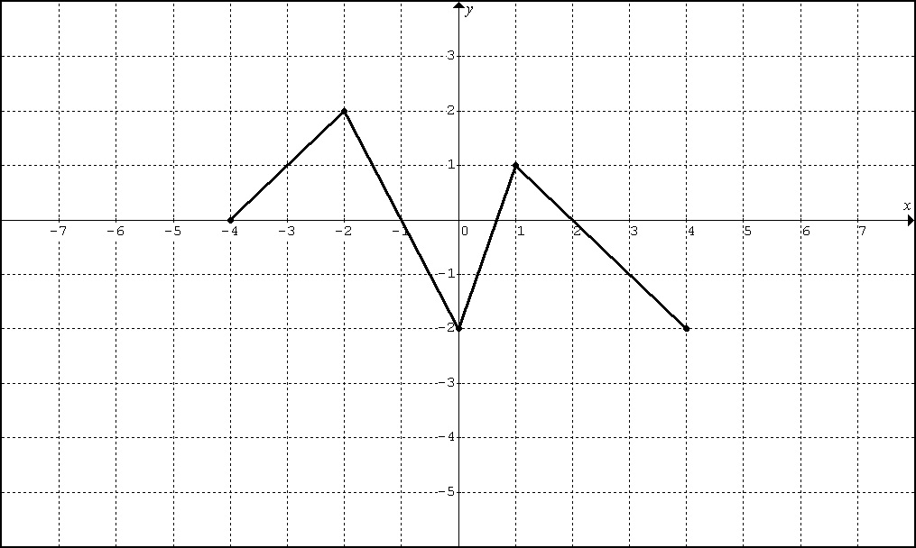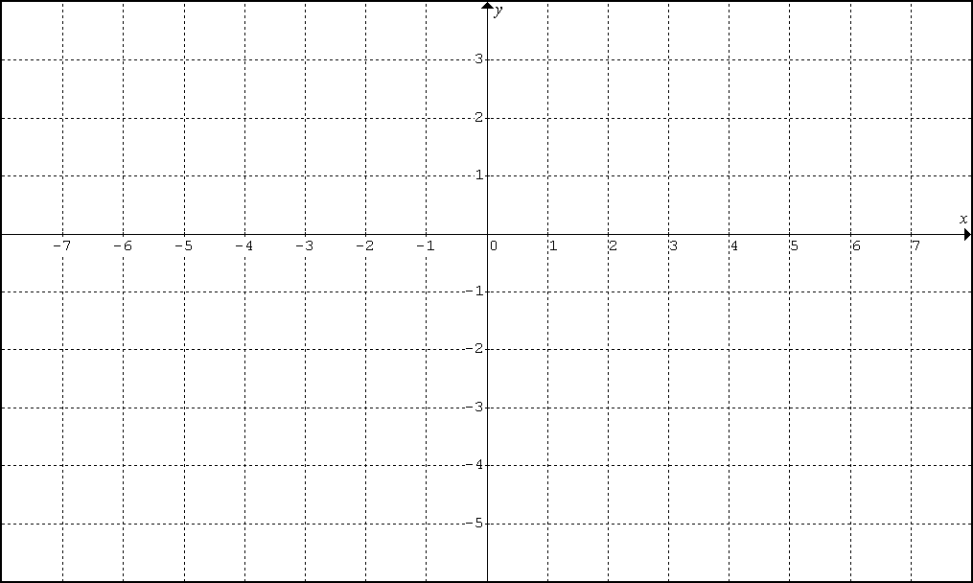

3. Graph $f(x)$ from $f^{}(x)$

Sketch a possible graph of a continuous function f that has domain [-3, 3], where $f(−1)=−2$and the equation of $y=f^{}(x)$is shown below.
$$f^{}(x)=\begin{aligned}\left\{−1; x<−1 | \right.\left\{0; −1<x<2 | \right.\end{aligned}$$

Property Problem

4. Let f be a function that is differentiable throughout its domain and that has the following properties.
(i) $f(x+y)=\frac{f(x)+f(y)}{1−f(x)f(y)}$for all real numbers x, y, and $x+y$ in the domain of f.
(ii) $\underset{h→0}{\text{lim}}f(h)=0$ (iii) $\underset{h→0}{\text{lim}}\frac{f(h)}{h}=1$

- Show that $f(0)=0\text{.}$
- Use the definition of the derivative to show that $f^{}(x)=1+[f(x)]^{2}$. Indicate where properties (i), (ii), and (iii) are used.

LESSON 2 – HW:

1. Use the table below to estimate a) $f^{}(1\text{.}\text{57})$ and b) $f^{}(3)$
t | 0.00 | 0.56 | 0.92 | 1.19 | 1.30 | 1.39 | 1.57 | 1.74 | 1.98 | 2.18 | 2.41 | 2.64 | 3.24
f(t) | 1577 | 1512 | 1448 | 1384 | 1319 | 1255 | 1191 | 1126 | 1062 | 998 | 933 | 869 | 805

2. Prove that $f(x)=\begin{aligned}\left\{x; x≤1 | \right.\end{aligned}$is or is not differentiable at $x=1$.
Classify $f(x)$as either smooth, a corner, a cusp, a vertical line tangent, or discontinuous at $x=1$.

3. Consider the function $b(x)=\begin{aligned}\left\{x; x>1 | \right.\end{aligned}$
a. Prove that b is or is not continuous at $x=1\text{.}$

b. Using the standard definition of a derivative at $x=a$, prove that f is not differentiable $x=1\text{.}$

c. Explain how you could have used part (a) to prove that f is not differentiable $x=1\text{.}$

4. Using the definition for a derivative at $x=a$,
prove that is or is not differentiable at $x=1$.
Classify as either smooth, a corner, a cusp, a vertical line tangent, or discontinuous at $x=1$.

5. Find the unique values of a and b that will make g both continuous and differentiable.
$$g(x)=\begin{aligned}\left\{3−x; x<1 | \right.\end{aligned}$$

6. The graph of the function $y=f(x)$shown here is made of line segments joined end to end.
Graph $y=f^{}(x)$and state its domain.
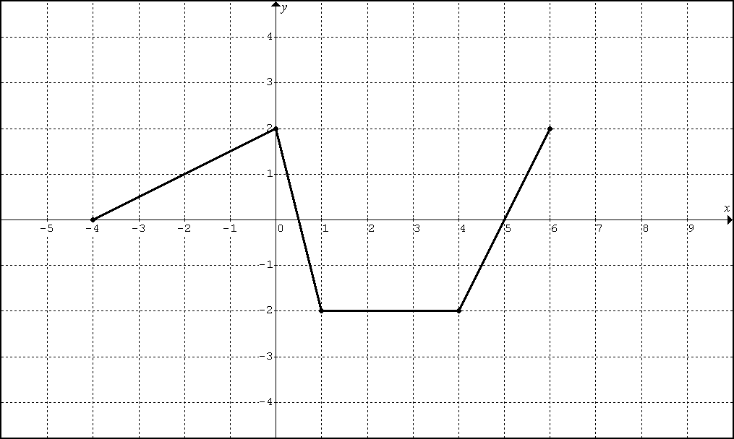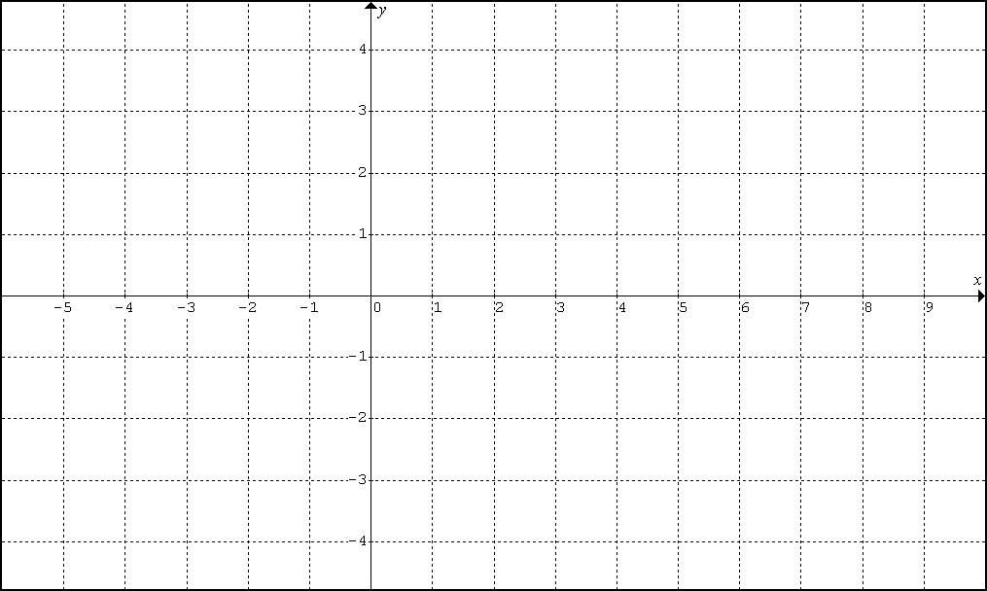

7. Sketch the graph of a continuous function with domain [-2,2],$f(0)=−1$, and $f^{}(x)=\begin{aligned}\left\{1; x<−1 | \right.\end{aligned}$.

8. Using the information from problem 7, write an equation of the line tangent to f at .

9. Find $f^{}(x)$ for $f(x)=5x^{2}−2x+1$ using the appropriate definition.

10. Find the value of x for which the tangent to $f(x)=5x^{2}−2x+1$ is horizontal.

11. Find $f^{}(x)$ for $f(x)=\frac{1}{x+1}$ using the appropriate definition.

12. Find $f^{}(x)$ for $f(x)=\sqrt{2x+1}$ using the appropriate definition.
13. Suppose that a function f is differentiable at $x=1$, $f(1)=0$, and $\underset{h→0}{\text{lim}}\frac{f(1+h)}{h}=5$. Find $f^{}(1)$.

14. Suppose that f is a differentiable function with the property that $f(x+y)=f(x)+f(y)+5\text{xy}$ and $\underset{h→0}{\text{lim}}\frac{f(h)}{h}=3$. Find $f(0)$and $f^{}(x)$.

Definitions

Is the function continuous at x = a?
DEF: A function f is continuous at $x=a$if and only if .

What is the derivative of f at x = a?

DEF (Sandard): The derivative of the function $f$at the point $x=a$is $f^{}(a)={\text{lim}}_{h→0}\frac{f(a+h)−f(a)}{h}$, provided it exists.

DEF (Alternate): The derivative of the function $f$at the point $x=a$is $f^{}(a)={\text{lim}}_{x→a}\frac{f(x)−f(a)}{x−a}$, provided it exists.

Is the function differentiable at x = a?

DEF (Std): A function f is differentiable at x = a if ${\text{lim}}_{h→0}\frac{f(a+h)−f(a)}{h}$exists.
If this limit does not exists then we say that the function is not differentiable at x = a.

DEF (alt): A function f is differentiable at x = a if ${\text{lim}}_{x→a}\frac{f(x)−f(a)}{x−a}$exists.
If this limit does not exists then we say that the function is not differentiable at x = a.

DEF: A function f is differentiable at the left endpoint $x=a$ iff $f_{+}^{}(a)={\text{lim}}_{h→0^{+}}\frac{f(a+h)−f(a)}{h}$

DEF: A function f is differentiable at right endpoint iff
$f_{−}^{}(b)={\text{lim}}_{h→0^{−}}\frac{f(b+h)−f(b)}{h}$.

DEF: A continuous function is a function that is continuous at each point in its domain.

DEF: A differentiable function is a function that is differentiable at each point in its domain.

DEF: A function is continuous on an interval I, if it is continuous at each point in the interval I.

DEF: A function is differentiable on an interval I, if f is differentiable at each point in the interval I.

