Q501. Advanced Integration Techniques

Review from the Course
Integration by Parts
Integration by Partial Fractions (Non-Repeating Linear)
Integration by Trigonometric Substitution

Additions (New to the Unit)
- Integration by Partial Fractions (Repeating and or Non-Linear)
- Irreducible Quadratic Expression in the Integrand
- Integration using reduction formulas (Proved with By-Parts)
- Trigonometric Integrals using Guidelines
- Trigonometric Integrals using Guidelines
- Miscellaneous Substitution: Integral contains an expression of the$\sqrt[n]{f\left(x\right)}$)
- Miscellaneous Substitution: Integrand is a rational expression in $\text{sin}x$and$\text{cos}x$)
- Integration using a Table of Integrals (Table in Supplemental Worksheet)

Lesson 1:
I. (Partial Fraction Decomposition)
Homework:
BC.Q501.LESSON1.HOMEWORK WORKSHEET #16, 17, 21, 22, 23

Lesson 2:
II examples # 1, 2
III examples #1, 2
IV example #1
V example #1
Homework:
IV. Examples #2, 3
V. Example #2
BC.Q501.LESSON2.HOMEWORK WORKSHEET #1, 2, 7, 15-23odd, Extra
Lesson3:
VI examples #1,2
VII examples #1, 2
VIII #1, 2
Homework:
BC.Q501.LESSON3.HOMEWORK WORKSHEET #6, 9, 39, 47, 59, Extra

Review from the Course

Integration by Parts
Example 1: Evaluate $\int{{\text{xe}}^{2x}\text{dx}\text{.}}$
Example 2: Evaluate $\int{x{\text{sec}}^{2}\text{xdx}}$
Example 3: Evaluate $\int{\text{ln}\text{xdx}}$
Example 4: Evaluate $\int{{\text{tan}}^{−1}x \text{dx}}$
Example 5: Evaluate $\int{x^{2}e^{2x}\text{dx}\text{.}}$
Example 6: Evaluate $\int{e^{x}\text{cos}\text{xdx}\text{.}}$
Example 7: Evaluate $\int{{\text{sec}}^{3}\text{xdx}\text{.}}$

Integration using Partial Fractions

Example 1: Evaluate $\int{\frac{2x+\text{16}}{x^{2}+x−6}\text{dx}}$
Example 2: Evaluate $\int{\frac{1−3x}{3x^{2}−5x+2}\text{dx}}$
Example 3: Evaluate $\int{\frac{5x+\text{14}}{x^{2}+7x}\text{dx}}$
Example 4: Evaluate $\int{\frac{x^{2}−6}{x^{2}−9}\text{dx}}$

Integration using a Trigonometric Substitution

Expression in Integrand | Trigonometric Substitution
$$\sqrt{a^{2}−x^{2}}$$ | $$x=a\text{sin}θ$$
$$\sqrt{a^{2}+x^{2}}$$ | $$x=a\text{tan}θ$$
$$\sqrt{x^{2}−a^{2}}$$ | $$x=a\text{sec}θ$$

Example 1: Evaluate $\int{\frac{\text{dx}}{x^{2}\sqrt{\text{16}−x^{2}}}}$
Example 2: Evaluate $\int{\frac{\text{dx}}{\sqrt{4+x^{2}}}}$
Example 3: Evaluate

I. Integration by Partial Fractions (Repeating and or Non-Linear)

Guidelines for Partial Fraction Decompositions of $f(x)/g(x)$

- If the degree of f(x) is not lower than the degree of g(x), use long division to obtain the proper form.

- Express g(x) as a product of linear factors $\text{ax}+b$ or irreducible quadratic factors ${\text{ax}}^{2}+\text{bx}+c$, and collect repeated factors so that g(x) is a product of different factors of the form $(\text{ax}+b)^{n}$or $({\text{ax}}^{2}+\text{bx}+c)^{n}$for a nonnegative integer n.

- Apply the following rules.

Rule a: For each factor $(\text{ax}+b)^{n}$ with $n≥1$, the partial fraction decomposition contains the sum of n partial fractions of the form

$\frac{A_{1}}{\text{ax}+b}+\frac{A_{2}}{(\text{ax}+b)^{2}}+⋅+\frac{A_{n}}{(\text{ax}+b)^{n}},$ where each numerator $A_{k}$ is a real number.

Rule b: For each factor $({\text{ax}}^{2}+\text{bx}+c)^{n}$ with $n≥1$ and with ${\text{ax}}^{2}+\text{bx}+c$irreducible, the partial fraction decomposition contains a sum of n partial fractions of the form

, where each $A_{k}$and $B_{k}$ is a real number.

Fraction Decomposition Examples: Decompose each fraction showing the appropriate denominators and appropriate numerators (here using A B C, etc.)
1. $\frac{4x^{2}+\text{13}x−9}{x^{3}+2x^{2}−3x}$

2. $\frac{3x^{3}−\text{18}x^{2}+\text{29}x−4}{(x+1)(x−2)^{3}}$

3. $\frac{x^{2}−x−\text{21}}{2x^{3}−x^{2}+8x−4}$

4. $\frac{5x^{3}−3x^{2}+7x−3}{(x^{2}+1)^{2}}$

5. Evaluate $\int{\frac{6x+7}{(x+2)^{2}}}\text{dx}$

II. Irreducible Quadratic Expression in the Integrand

Example 1: Evaluate $\int{\frac{2x−1}{x^{2}−6x+\text{13}}\text{dx}}$

Example 2: Evaluate $\int{\frac{1}{\sqrt{x^{2}+8x+\text{25}}}\text{dx}}$
III. Integration using reduction formulas (Proved with By-Parts)

Example 1: Find a reduction formula for $\int{{\text{sin}}^{n}x }\text{dx}$

Example 2: Use the reduction formula in Example 8 to evaluate $\int{{\text{sin}}^{5}x }\text{dx}$

Reduction Formulas:

IV. Trigonometric Integrals $\int{{\text{sin}}^{m}x{\text{cos}}^{n}x \text{dx}}$

Guidelines:

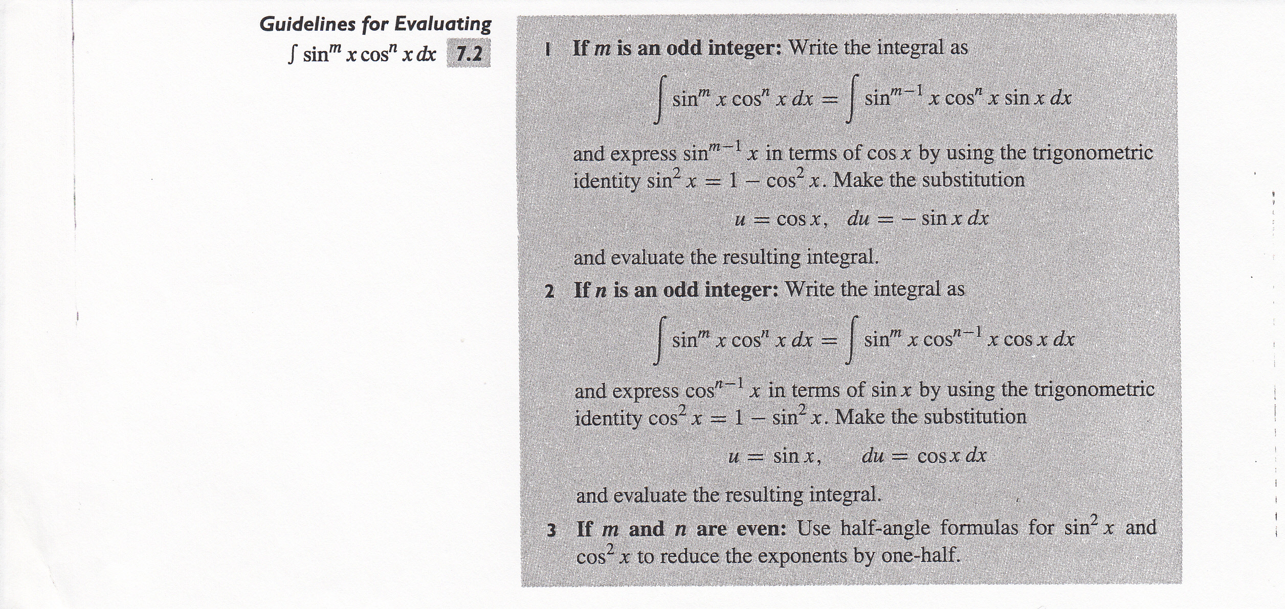

Example 1: Evaluate $\int{{\text{sin}}^{5}x }\text{dx}$ without using “by parts.”

Example 2: Evaluate $\int{{\text{cos}}^{2}x \text{dx}}$without using “by parts.”

Example 3: Evaluate $\int{{\text{cos}}^{3}x{\text{sin}}^{4}x \text{dx}}$

V. Trigonometric Integrals $\int{{\text{tan}}^{m}x{\text{sec}}^{n}x \text{dx}}$

Guidelines:
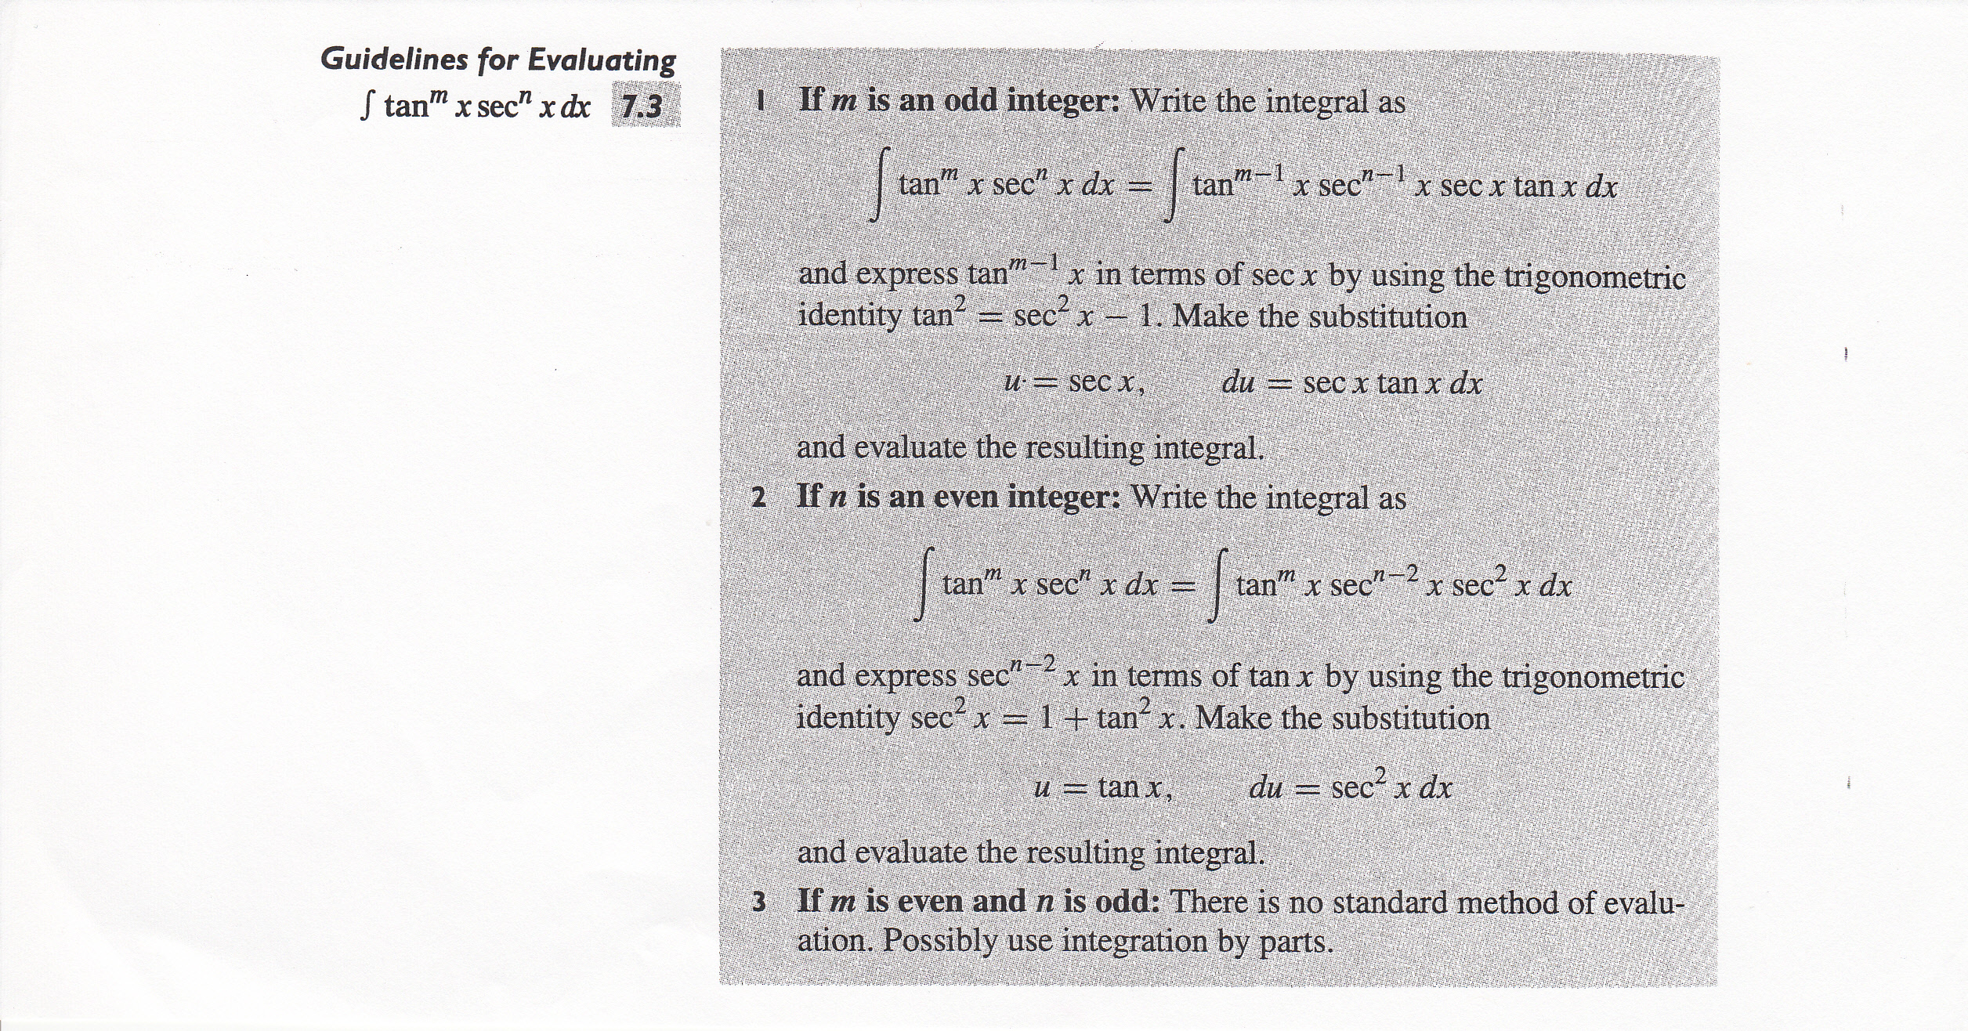

Example 1: Evaluate $\int{{\text{tan}}^{3}x {\text{sec}}^{5}x}\text{dx}$.

Example 2: Evaluate $\int{{\text{tan}}^{2}x {\text{sec}}^{4}\text{xdx}}$.

VI. Miscellaneous Substitutions (Integral contains an expression of the $\sqrt[n]{f\left(x\right)}$)

Example 1: Evaluate $\int{\frac{x^{3}}{\sqrt[3]{x^{2}+4}}\text{dx}}$

Example 2: Evaluate $\int{\frac{1}{\sqrt{x}+\sqrt[3]{x}}\text{dx}}$

VII. Miscellaneous Substitution (Integrand is a rational expression in $\text{sin}x$and $\text{cos}x$)

Example 1: Evaluate$\int{\frac{1}{4\text{sin}x−3\text{cos}x}\text{dx}}$

Example 2: Evaluate $\int{\frac{\text{cos}x}{1+{\text{sin}}^{2}x}\text{dx}}$

VIII. Integration using Table of Integration

Example 1: Evaluate $\int{\frac{1}{x^{2}\sqrt{3+5x^{2}}} \text{dx}}$ for $x>0$ using the brief table of integration.

Example 2: Evaluate $\int{x^{3}\text{cos}x \text{dx}}$ using the brief table of integration.

BC.Q501.LESSON1.HOMEWORK WORKSHEET
Evaluate each integral.
16.
17.
21.
22.
23.

BC.Q501.LESSON2.HOMEWORK WORKSHEET
1. DO NOT EVALUATE. Determine which approach (u-substitution, integration by parts, partial fractions, reduction formulas, and trigonometric substitution) you would try first to evaluate.
A.
B.
C.
D.
E.
F.
G.
H.
I.
2. DO NOT EVALUATE. Determine the appropriate trigonometric substitution needed to evaluate each.
A.
B.
C.
D.
E.
F.
7. In each part, evaluate the integral by making an appropriate substitution and applying a reduction formula.
A.
B.
15-23 ODD --- Evaluate Each:
15.
17.
19.
21.
23.

Extra. Evaluate:

BC.Q501.LESSON3.HOMEWORK WORKSHEET
6. Evaluate the integral using …
A. Integration by Parts
B. The substitution

9. Evaluate the integral in each of the three ways …
A. B. C. Completing the Square

39. Make a substitution to express the integrand as a rational function and then evaluate the integral.
47. Make a substitution to express the integrand as a rational function and then evaluate the integral.
59. Use the substitution $θ=\text{tan}(x/2)$to evaluate the integral.

Extra: Evaluate the integral.

