BC. Q204. Chapter 6: Lesson 1 (6.1, 6.2, 6.4)
[Separable Differential Equations]

SOLVE EACH DIFFERENTIAL EQUATION

1. $\frac{\text{dy}}{\text{dx}}=−\frac{x}{y}$ where $y=−3$when $x=4$.

2. $f^{}(x,y)=\frac{\text{xy}}{8}$ where $y(0)=5$.

3. $f^{}(x,y)=e^{x−y}$ where $y(1)=\text{ln}(e+2)$

4. $\frac{\text{dy}}{\text{dx}}=5y$ where $y=9$when $x=0$.

5. $\frac{\text{dy}}{\text{dx}}=4(6+y)$ where $y=9$when $x=0$.

6. $\frac{\text{dy}}{\text{dx}}=\frac{1}{3}(5−y)$ where $y=8$when $x=0$.

GROWTH/DECAY MODELS – WORD PROBLEMS

Biological Growth: The number cells in a certain bacteria grow at a rate directly proportional to the existing number of cells in the population. There are 500 cells initially and the number of cells doubles every 2.5 hours.
(A) Find a model for the number of cells in terms of time t and constant of proportionality k.
(B) Find k and simplify your model. Provide a quick sketch.
(C) How many cells will there be after 10 hours?
(D) How long would it take the initial population to grow to 16,000 bacteria?

Newton’s Law of Cooling: The rate of change in temperature of water in a cup is directly proportional to the difference between the room’s temperature and the actual temperature of the water. A cup of water with temperature 100ºC is placed in a room with constant temperature 20ºC. The water cools to 60ºC in one minute.
(A) Find a model for the temperature of the water in terms of time t and constant of proportionality k.
(B) Find k and simplify your model. Provide a quick sketch.
(C) What is the temperature of the water after 2 minutes?
(D) How long will it take for the temperature to reach 25ºC?

Bermy Fish: The length of a Bermy fish grows at a rate that is directly proportional to the difference between its theoretical maximum length of 12 inches and its actual length. A Bermy fish is hatched at 0.5 inches. A typical Bermy fish has a length of 6 inches in 20 weeks.
(A) Find a model for the length of a Bermy fish in terms of time t and constant of proportionality k.
(B) Find k and simplify your model. Provide a quick sketch.
(C) What is the length of a typical Bermy fish be after 50 weeks? (Expression only)
(D) How long will it take a typical hatched Bermy fish to grow to be 9 inches? (Expression only)

ADDITIONAL PRACTICE

1. $\frac{\text{dy}}{\text{dx}}=7(3−y)$ where $y=1$when $x=0$.

2. $\frac{\text{dy}}{\text{dx}}=3\sqrt{\text{xy}}$where$y=\text{256}$when $x=4$.

3. $\frac{\text{dy}}{\text{dx}}={\text{cos}}^{2}y$ where $y=0$when $x=0$.

4. $\frac{\text{dy}}{\text{dx}}=\frac{4\sqrt{y}\text{ln}x}{x}$ where $y=4$when $x=e$.
BC: Q204 LESSON 1 HOMEWORK

Solve each differential equation (show all work on a separate sheet of paper):

EXPONENTIAL and SIMPLE BOUNDED GROWTH MODELS

1. $\frac{\text{dy}}{\text{dt}}=5(\text{10}−y)$ where $y=7$when $t=0$.

2. $\frac{\text{dy}}{\text{dt}}=\frac{1}{2}(5−y)$ where $y=8$when $t=0$.

3. $\frac{\text{dy}}{\text{dt}}=8(2+y)$ where $y=1$when $t=0$.

4. $\frac{\text{dy}}{\text{dt}}=−4(3−y)$ where $y=6$when $t=0$.

5. $\frac{\text{dy}}{\text{dt}}=0\text{.}4y$ where $y=6$when $t=0$.

MATH MODELS

1. $\frac{\text{dy}}{\text{dx}}=\frac{x}{y}$ where $y=2$when $x=1$.

2. $\frac{\text{dy}}{\text{dx}}=\frac{y}{x}$ where $y=2$when $x=2$.

3. $\frac{\text{dy}}{\text{dx}}=\text{xy}$ where $y=2$when $x=1$.

4. $\frac{\text{dy}}{\text{dx}}=\frac{1}{\text{xy}}$ where $y=−4$when $x=1$.

5. $\frac{\text{dy}}{\text{dx}}=\left(y+5\right)\left(x+2\right)$ where $y=1$when $x=0$.

6. $\frac{\text{dy}}{\text{dx}}=\left(\text{cos}x\right)e^{\left(y+\text{sin}x\right)}$ where $y=0$when $x=0$.

7. $\frac{\text{dy}}{\text{dx}}=−2{\text{xy}}^{2}$ where $y=\frac{1}{4}$when $x=1$
GROWTH/DECAY WORD PROBLEMS

1 WOLVES: Letrepresent the number of wolves in a population at time t years. The rate at which the wolf population grows is directly proportional to where the constant of proportionality is k.

A. If there were 500 wolves initially, find the function in terms of t and k.
B. If there are 700 wolves in 2 years, find k and write the simplified model.
Provide a quick sketch.
C. How many wolves (to the nearest whole number) does the model predict there will be at time years?
D. Find .

2 MEL SNAKE: The length of a Mel snake grows at a rate that is directly proportional to the difference between its theoretical maximum length of 40 inches and its actual length. A Mel Snake is hatched at 2 inches and has a length of 21 inches in 4 months.
(A) Find a model for the length of a Mel snake in terms of time t and constant of proportionality k.
(B) Find k and simplify your model. Provide a quick sketch.
(C) How long will it take a typical hatched Mel snake to grow to be 35.25 inches?
Note:

3 NEWTON’S LAW OF COOLING: The rate of change in temperature of an egg in running water is directly proportional to the difference between the running water’s temperature and the actual temperature of the egg. An egg with temperature 98ºC is placed under running water with constant temperature 18ºC. The egg cools to 38ºC in five minutes.
(A) Find a model for the temperature of the water in terms of time t and constant of proportionality k.
(B) Find k and simplify your model. Provide a quick sketch.
(C) How long will it take for the temperature to reach 20ºC? (Expression Only)

4 JAYS AMAZING GREEN GLOB: Let represent the volume of Jay’s Amazing Green Glob which grows at the rate cm³/min once it has been opened from its plastic container. Suppose Aaron opens a container of Jay’s Amazing Green Glob which has an initial volume of 100 cubic centimeters.
(A) What will be the volume of the glob 2 minutes after it is opened?
(B) What is the maximum volume the glob can grow to be?
BC. Q204 Chapter 6: Lesson 2 [Slope Fields and Euler’s Method]

LINEAR APPROXIMATION and EULERS METHOD OF APPROXIMATION

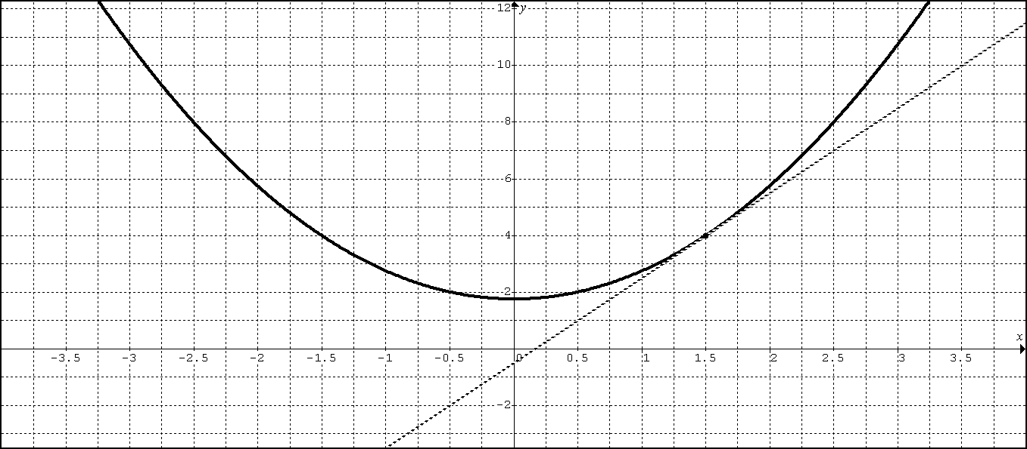
1. Suppose where is the solution to the differential equation that passes through the point .
A. Write an equation of the line tangent to the curve at and use it to approximate .

B. Starting at the point (1.5, 4), use Euler’s Method with step size to approximate .

C. Find the exact value of .
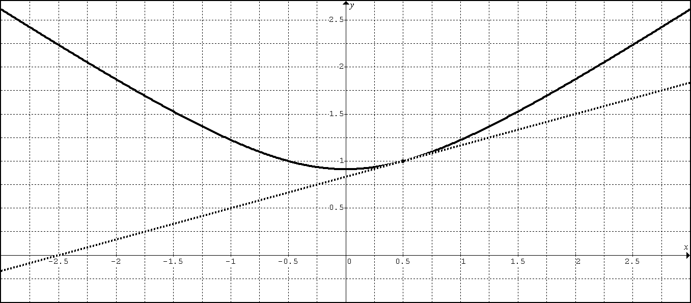
2. Suppose where is the solution to the differential equation that passes through the point .
A. Write an equation of the line tangent to the curve at and use it to approximate .

B. Starting at the point (0.5, 1), use Euler’s Method with step size to approximate .

C. Find the exact value of .
1. Consider the derivative equation:
Letbe the solution to the differential equation that passes through the point (1,2).
A. Sketch the slope field on the given points.
B. Sketch the solution curve that passes through the point (1,2).
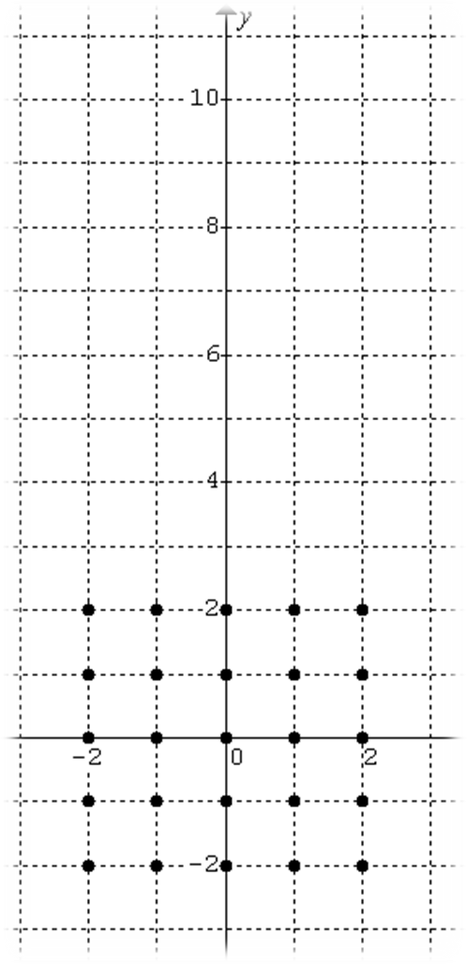

C. Write an equation of the line tangent to the solution curve at the point (1,2).

D. Use the linearization found in part C to estimate

E. Find the general solution to the differential equation.

F. Find the particular solution to the differential equation that passes through the point (1,2).

G. Use the particular solution found in part F to find the exact value of

H. Find at the point (-1, 5) for the solution curve that passes through the point (-1, 5) and indicate the implications of its numeric value on this solution curve and subsequent linear approximations.

2. Consider the derivative equation:
Letbe the solution to the differential equation that passes through the point (1,-1).
A. Sketch the slope field on the given points.
B. Sketch the solution curve that passes through the point (1,-1).
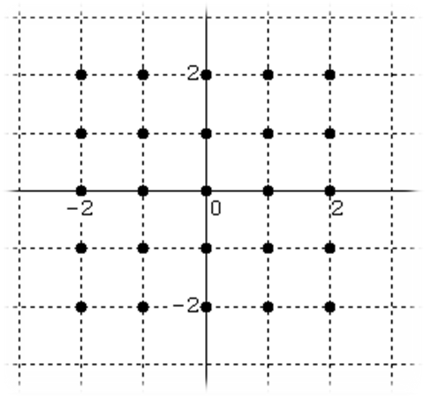

C. Write an equation of the line tangent to the solution curve at the point (1,-1).

D. Use the linearization found in part C to estimate

E. Find the general solution to the differential equation.

F. Find the particular solution to the differential equation that passes through the point (1,-1).

G. Use the particular solution found in part F to find the exact value of

H. Find at the point (-1, 5) for the solution curve that passes through the point (-1, 5) and indicate the implications of its numeric value on this solution curve and subsequent linear approximations.

3. Consider the derivative equation:
A. Sketch the slope field on the given points.
B. Sketch the solution curve that passes through the point (0,2).
C. Sketch the solution curve that passes through the point (0,-1).

Letbe the solution to the differential equation at the point (-2,2).
D. Write an equation of the line tangent to the solution curve at the point (-2,2).

E. Use the linearization found in part D to estimate

F. Find at the point (-1, 5) for the solution curve that passes through the point (-1, 5) and indicate the implications of this numeric value on this solution curve and subsequent linear approximations.
4. Let with solution . If , find and .
BC Q204: LESSON 2
ESSENTIAL HW (NO CALCULATOR)
#1: Let be a function with such that for all points (x, y) on the graph of the slope is given by.

- Find the slope of the graph of at the point where x = 1.
- Write an equation for the line tangent to the graph of at x = 1 and use it to approximate f(1.2)
- Findand explain the implications of its value to the linear approximation found in part (b).
- Starting at the point (1, 4), use Euler’s Method with step size to approximate .
- Find by solving the separable differential equation with initial condition.
#2: Consider the differential equation given by.

- On the axes provided below, sketch a slope field for the given differential equation at the nine points indicated.

1
-1
1
2
3

- Let be a particular solution to the given differential equation with initial condition. Use Euler’s method starting at x = 0, with step size 0.1, to approximate. Show the work that leads to your answer.
- Find and explain the implications of its value to the approximation found in part (b)
- Starting at the point (0, 3), use Euler’s Method with step size to approximate .
- Find the particular solution to the given differential equation with initial condition

#3. Consider the differential equation $\frac{\text{dy}}{\text{dx}}=y+x$ with $y(0)=1$.

A. Use a linearization centered at $x=0$to approximate$y(1\text{.}2)$.

B. Use Euler’s method starting at $x=0$ with step size $Δx=0\text{.}4$ to approximate$y(1\text{.}2)$.

ADDITIONAL HW (NO CALCULATOR)

4. Consider the differential equation $\frac{\text{dy}}{\text{dx}}=e^{y}\left(3x^{2}−6x\right)$. Let $y=f(x)$ be the particular solution to the differential equation that passes through (1, 0).

A. Write an equation for the line tangent to the graph of f at the point (1, 0). Use the tangent line to approximate $f(1\text{.}2)$.
B. Find $f^{\text{//}}(1)$and explain the implications of its value to the approximation found in part (A).
C. Find $y=f(x)$, the particular solution to the differential equation that passes through (1, 0).

5 Consider the differential equation: $\frac{\text{dy}}{\text{dx}}=x(2−y)$
A. Find the particular function $y(x)$ if $y(0)=5$.

B. Find $\underset{x→∞}{\text{lim}}y(x)$for $y(x)$found in part A.

C. Use a linearization, centered at $x=0\text{.}5$ to approximate $y(1\text{.}5)$if $y(0\text{.}5)=2\text{.}5$

D. Find $\frac{d^{2}y}{{\text{dx}}^{2}}$ at the point (0.5, 2.5). Will the approximation in part “C” be an over or under estimate? Justify.

E. Draw the slope field for the 9 indicated points.
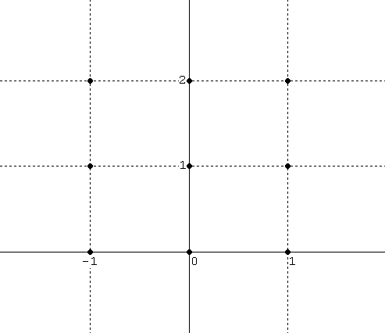
6. Find the general solution to each differential equation.
A. $\frac{\text{dy}}{\text{dx}}=\frac{x}{y^{2}}$ B. $\frac{\text{dy}}{\text{dx}}=\frac{{\text{xy}}^{2}}{1+x^{2}}$ C. $\frac{\text{dy}}{\text{dx}}=\frac{8y}{x(x−2)}$
BC. Q204. Chapter 6: Lesson 3 (6.5)
Logistic Growth
The solution to the differential equation $\frac{\text{dy}}{\text{dt}}=\text{Ky}(L−y)$ is $y=\frac{L}{1+C∗e^{−\text{LKt}}}$
where L is the carrying capacity and $K=\frac{k}{L}$where k is the constant of proportionality.

Let $y=\frac{L}{1+C∗e^{−\text{LKt}}}$ and let

1. Draw a slope field for $y$:

2A. DRAW
Draw y for $0<y_{0}<L$

Draw y for

Draw y for

2B. Find $\underset{t→∞}{\text{lim}}y$

2C. Find $\underset{t→−∞}{\text{lim}}y$

3. Let $0<y_{0}<L$: What is the value of y when y is growing fastest?
Example 1: If $\frac{\text{dP}}{\text{dt}}=0\text{.}\text{0004}P(\text{250}−P)$and $P(0)=\text{50}$, find the function $P(t)$.

Example 2: If $\frac{\text{dP}}{\text{dt}}=\text{100}P−5P^{2}$ and $P(0)=3$, find the function $P(t)$.

Example 3: If $\frac{\text{50}}{P}\frac{\text{dP}}{\text{dt}}=2−\frac{P}{\text{250}}$ and $P(0)=\text{25}$, find the function $P(t)$.
Example 4: Because of the limited food space, a squirrel population and $P(t)$cannot exceed 1000. $P(t)$grows at a rate proportional both to the existing population and to the attainable additional population. If there were 100 squirrels 2 years ago, and 1 year ago the population was 400, about how many are there now? What is the squirrel population when it is growing the fastest?

PROOF: Use separation of variables to prove that the general solution to $\frac{\text{dy}}{\text{dt}}=\text{Ky}(L−y)$ is $y=\frac{L}{1+C∗e^{−\text{LKt}}}$.
LESSON 3 HOMEWORK (LOGISTIC MODEL)

1. Let $\frac{\text{dP}}{\text{dt}}=0\text{.}\text{006}P(\text{200}−P)$with initial condition P = 8 people when t = 0 years.

A. Write the function P(t).

B. What is the size of the population when it is growing its fastest?

C. What is the rate at which the population is growing when it is growing the fastest?

D. Find ${\text{lim}}_{t→∞}P(t)$

2. Let $\frac{\text{dP}}{\text{dt}}=\text{1200}P−\text{100}P^{2}$ with initial condition P = 4 eggs when t = 0 months.

A. Write the function P(t).

B. What is the size of the population when it is growing its fastest?

C. What is the rate at which the population is growing when it is growing the fastest?

D. Find ${\text{lim}}_{t→∞}P(t)$

3. A certain rumor spreads through a community at the rate $\frac{\text{dy}}{\text{dt}}=2y(1−y)$, where y is the proportion of the population that has heard the rumor at time t hours.

(a) What proportion of the population has heard the rumor when it is spreading the fastest?

(b) If ten percent of the people have heard the rumor at time t = 0, find y as a function of t.

(c) At what time t is the rumor spreading the fastest?

4. If $\frac{\text{dP}}{\text{dt}}=\text{100}P−5P^{2}$ and $P(0)=3$, find the function $P(t)$and the values of $P^{}(0)$and $P^{\text{//}}(0)$.

BC LESSON 4: Q204 – CHAPTER 6: PRACTICE EXAM

#1 (No Calculator) Let where .
A. Solve the differential equation by separating the variables
B. Find in terms of y and use it to find at .

#2 (No Calculator) Let where .
A. Solve the differential equation by separating the variables
B. Find in terms of y and use it to find at .

#3 (No Calculator) Let where .
A. Solve the differential equation by separating the variables.
B. Draw a slope for the indicated point in the graph below.

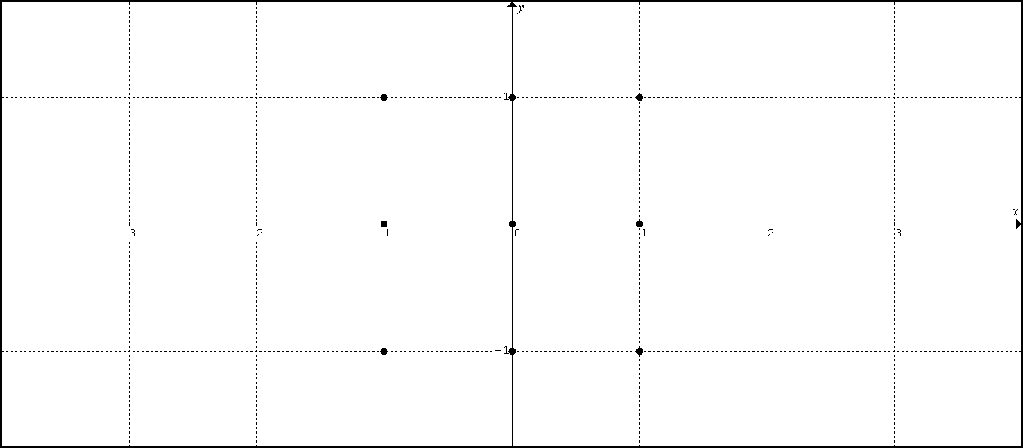

#4 (No Calculator)
Let where is the particular solution to the differential equation with the initial condition . Find and .
#5 (No Calculator) Consider the differential equation. Let be the particular solution to the differential equation with the initial condition . The function f is defined for all real numbers.

(a) A portion of the slope field of the differential equation is given below. Sketch the solution curve through the point (0, 1).

(b) Write an equation for the line tangent to the solution curve in part (a) at the point (0, 1). Use the equation to approximate

(c) Find , the particular solution to the differential equation with initial condition .

#6. Consider the differential equation $\frac{\text{dy}}{\text{dx}}=x^{2}−\frac{1}{2}y$
Let $y=h(x)$be the particular solution to the differential equation with $h(0)=2$.
A. Use a linearization centered at $x=0$ to approximate $h(1)$.
B. Use Euler’s method, starting at $x=0$with two steps of equal size, to approximate $h(1)$.
C. Is the graph of $y=h(x)$concave upward or concave downward at $x=0$? Justify.

#7. Consider the differential equation $\frac{\text{dy}}{\text{dx}}=y^{2}\left(2x+2\right)$
Let $y=f(x)$be the particular solution to the differential equation with $f(0)=−1$.
A. Use Euler’s method, starting at $x=0$with two steps of equal size, to approximate $f\left(\frac{1}{2}\right)$.
B. Find $y=f(x)$, the particular solution to the differential equation with initial condition $f(0)=−1$.

#8: If $\frac{\text{dP}}{\text{dt}}=0\text{.}\text{001}P(\text{25}−P)$and $P(0)=\text{15}$…
A. Find the function $P(t)$. Provide a quick sketch.
B. Find the value of P when $\frac{\text{dP}}{\text{dt}}$is at its greatest.

#9: If $\frac{\text{dP}}{\text{dt}}=\text{40}P−5P^{2}$ and $P(0)=3$…
A. Find the function $P(t)$.
B. Find the value of $\frac{\text{dP}}{\text{dt}}$ when $\frac{\text{dP}}{\text{dt}}$is at its greatest.

#10: If $\frac{\text{40}}{Z}\frac{\text{dZ}}{\text{dt}}=5−\frac{Z}{\text{60}}$ and $Z(0)=\text{25}$ …
A. Find the function $Z(t)$.
B. Find $\underset{t→∞}{\text{lim}}Z(t)$.

#11. (No Calculator) Let represent the number of rats in a farm house at time t days. The rate at which the rat population grows is directly proportional to the number of rats present where the constant of proportionality is k.

A. If there were 24 rats initially, find the function in terms of t and k.
B. If there are 72 rats in 2 days, find k.
C. How many rats would we expect to find after 8 days?

#12. (No Calculator) Let represent the temperature (degrees Celsius) of tea in a cup at time t minutes, with . The temperature is changing at a rate directly proportional to the difference between the room temperature (20ºC) and the temperature of the tea, i.e. where the constant of proportionality is k.

A. If the tea is poured with an initial temperature of 100 degrees Celsius, find in terms of t and k.
B. If the tea cools to 60 degrees Celsius in 3 minutes, find k.
C. What will be the temperature of the tea after 6 minutes?
D. At what time will the temperature reach 30 degrees Celsius?

