CALCULATOR ORIENTATION: ALGEBRA CALCULATOR SKILLS

Use your TI89 to complete the following tasks:

1. Evaluate $\frac{5}{2}$

2. Solve $3x^{2}+\text{13}x−\text{10}=0$

3. Solve $3x^{2}+2x+\text{10}=0$

4. Factor $2x^{3}+\text{13}x^{2}+\text{13}x−\text{10}$

5. Expand $(x+2)^{2}(x−4)$

CALCULATOR ORIENTATION: AP CALCULATOR SKILLS
Consider the function $f(x)=\text{tan}\left(x^{2}+1\right)+x^{5}$on the domain $[−5,5]$.

1. Graph the function $f(x)$and find the zero(s).

2. Find the derivative function $f^{}(x)$.

3. Evaluate the derivative at $x=2\text{.}5$, i.e. find $f^{}(2\text{.}5)$.

4. Use the graph of the derivative to count the number of zeros of $f^{}(x)$ on the domain $[−1\text{.}5, 1\text{.}5]$
BC Q201: CH4 DERIVATIVE APPLICATIONS
Lesson 1: VELOCITY and ACCELERATION APPLICATIONS

1. The graph shows the velocity of a particle moving along a horizontal coordinate axis.
NO TECHOLOGY:

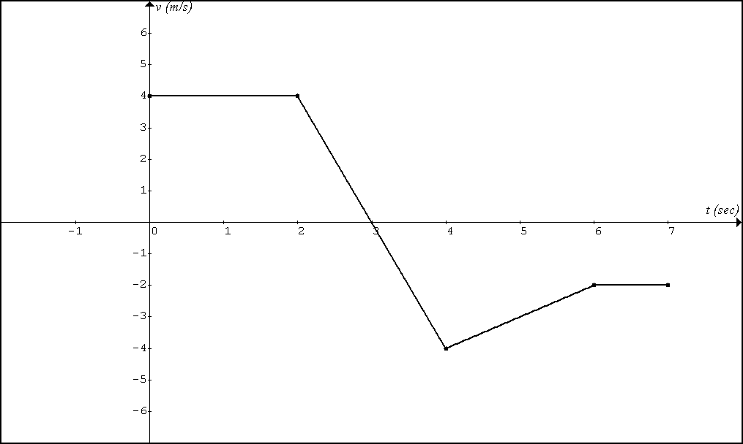

A. At what time on the interval (0,7) is the particle standing still? Justify.

B. On what interval is the particle moving right? Justify.

C. On what interval is the particle moving left? Justify.

D. On what interval is the acceleration positive? Justify.

E. On what interval is the particle getting faster? Justify.

2. The graph shows the velocity of a particle moving along a vertical coordinate axis.
NO TECHOLOGY:
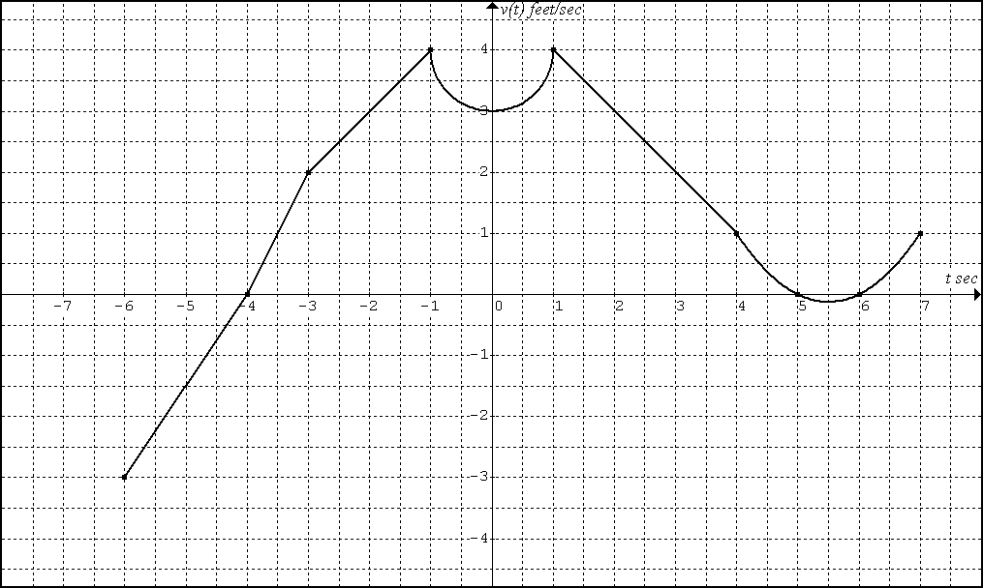

A. At what time on the interval (-6,7) is the particle standing still? Justify.

B. On what interval is the particle moving up? Justify.

C. On what interval is the particle moving down? Justify.

D. On what interval is the acceleration positive? Justify.

E. On what interval is the particle getting slower? Justify.

F. What are the velocity and acceleration at time t = 2?

G. What are the velocity and acceleration at time t = 0?
3. The velocity of a particle moving along a horizontal coordinate axis is defined by for .
TECHOLOGY REQUIRED:

A. At what time on the interval (-2,2) is the particle standing still? Justify.

B. On what interval is the particle moving right? Justify.

C. On what interval is the particle moving left? Justify.

D. On what interval is the acceleration positive? Justify.

E. On what interval is the particle getting slower? Justify.

G. What are the velocity and acceleration at time t = 0?

4. The velocity of a particle moving along a horizontal coordinate axis is defined by for .
TECHOLOGY REQUIRED:

A. At what time on the interval (0,2) is the particle standing still? Justify.

B. On what interval is the particle moving right? Justify.

C. On what interval is the particle moving left? Justify.

D. On what interval is the acceleration positive? Justify.

E. On what interval is the particle getting faster? Justify.

G. What are the velocity and acceleration at time t = 1?

5. The position of a particle moving along a horizontal coordinate axis is defined by for . NO TECHOLOGY:
A. At what time on the interval (-5,5) is the particle standing still? Justify.

B. On what interval is the particle moving right? Justify.

C. On what interval is the particle moving left? Justify.

D. On what interval is the acceleration positive? Justify.

E. On what interval is the particle getting faster? Justify.

G. What are the position, velocity, and acceleration at time t = 1?

6. The position of a particle moving along a horizontal coordinate axis is defined by for . NO TECHOLOGY:
A. At what time on the interval (0,2) is the particle standing still? Justify.

B. On what interval is the particle moving right? Justify.

C. On what interval is the particle moving left? Justify.

D. On what interval is the acceleration positive? Justify.

E. On what interval is the particle getting slower? Justify.

G. What are the position, velocity, and acceleration at time t = 1?

BC CALCULUS Q201: Lesson 2
CH 4. The First Derivative Test

Assume f is continuous on [a, b]

Relative Extremes on (a, b) (First Derivative Test)

There is a relative max at because

There is a relative min at because

Relative Extremes on [a, b] (Endpoints are always relative Extremes)

There are relative extremes at x = a and x = b because there are endpoints at x = a and x = b.

Absolute Extremes

is the absolute max because

is the absolute min because

Absolute Extremes (Closed Interval Test)

Find all relative extremes on a closed interval.

Absolute Max: The absolute max is the largest of all the relative extremes.

Absolute Min: The absolute min is the smallest of all the relative extremes.

Intervals of Increasing or Decreasing

f is increasing on because

f is decreasing on because

NON – TECHNOLOGY SECTION
1. Let $f(x)=5−7x−4x^{2}$.
A. Find the x-values where $f(x)$has relative extremes. Justify using the first derivative test.

B. Find the interval on which $f(x)$is decreasing. Justify.

2. Let $f(x)=\text{10}x^{3}(x−1)^{2}$
A. Find the x-values where $f(x)$has relative extremes. Justify using the first derivative test.

B. Find the interval on which $f(x)$is increasing. Justify.

3. Let $f(x)=\frac{1}{2}x−\text{sin}x$ on the closed interval $\left[0, 2π\right]$
A. Find the absolute extremes using the closed interval test.

TECHNOLOGY SECTION
1. Let $f^{}(x)=8+2x−e^{x^{2}}$on (-2, 2)

A. Find the x-value(s) of any local maximums. Justify using the first derivative test.

B. On what interval is f decreasing? Justify.

2. Let $f^{}(x)=\text{cos}(x^{3})$on (0, 2)
A. Find the x-value(s) of any local minimums. Justify using the first derivative test.

B. On what interval is f decreasing? Justify.

C. Suppose the function $f^{}(x)=\text{cos}(x^{3})$was extended to have the domain [0,2].

f has a local _____ at x = 0. A. max, max B. max, min

f has a local _____ at x = 2 C. min, max D. min, min
Q203. Lesson2.Homework

NO TECHNOLOGY PERMITTED
1. $f(x)=−2x^{3}+6x^{2}−3$
a. Find the interval on which f is decreasing. Justify
b. Use the first derivative test to find the x-values of any local extremes.
c. What are the local extremes?

2. $f(x)=x+2\text{cos}(x)$on $\left[0, 2π\right]$
a. Find the interval on which f is increasing. Justify
b. Use the first derivative test to find the x-values of any local extremes on (0, 2π).
c. Will f(0) be a local max or min? Will f(2π) be a local min or max?
d. Find the absolute extremes using the closed interval test.

3. (Tricky) $f(x)=x\sqrt{x^{2}−9}$
a. Find the interval on which f is decreasing. Justify
b. Find the x-values of any local extremes.

TECHNOLOGY REQUIRED
4. $f^{}(x)=x−\text{cos}(πx)−\text{sin}x$ on $\left(−1,1\right)$
a. Graph $f^{}(x)$
b. Find the zeros of $f^{}(x)$.
c. Find the interval on which f is increasing. Justify.
d. Indicate the x-value(s) where f has a local max. Justify.

5. $f^{}(x)=5e^{{−x^{2}}/2}−1$ on $\left(−3,3\right)$
a. Graph $f^{}(x)$
b. Find the zeros of $f^{}(x)$.
c. Find the interval on which f is increasing. Justify.
d. Indicate the x-value(s) where f has a local max. Justify.

6. $f^{}(x)=\frac{x}{\text{20}}\text{cos}(x^{2})$ on $\left[−2, 2\right]$
a. Graph $f^{}(x)$
b. Find the zeros of $f^{}(x)$.
c. Find the interval on which f is increasing. Justify.
d. Indicate the x-value(s) where f has a local min. Justify.

AP QUESTION: 1990-AB5 (NO CALCULATOR) (CLOSED INTERVAL TEST)

BC Q201: CH4 DERIVATIVE APPLICATIONS
Lesson 3: The Second Derivative - Applications

The First Derivative Test is for ____________________________________________.

The Second Derivative Test is for __________________________________________.

The Concavity test is for __________________________________________________.

The Point of Inflection test is for ____________________________________________.

CONCAVITY:

CONCAVITY TEST:

POINTS OF INFLECTION:

POINTS OF INFLECTION TEST:

SECOND DERIVATIVE TEST:

NO TECHNOLOGY
Use the 2nd derivative test to find the x-value where the function has a relative maximum and or minimum.

Example 1:

Example 2:

Example 3:

Example 1 Continued:
A. Use the concavity test to determine on what interval the function is concave up.
B. Use the point of inflection test to identify the x-values of any point of inflection.

Example 2 Continued:
A. Use the concavity test to determine on what interval the function is concave down.
B. Use the point of inflection test to identify the x-values of any point of inflection.

.

1992 AP 1
Let f be the function defined by .
- On what intervals is f increasing? Justify.
- On what intervals is the graph of f concave upward? Justify.
- Write the equation of each horizontal tangent line to the graph of f.

TECHNOLOGY REQUIRED
Consider the derivative of the function on the interval (1,4)
on (1,4)

A. On what interval if f decreasing? Justify your answer.

B. For what values of x does f has a local maximum? Justify your answer.

C. On what interval is f concave down? Justify your answer.

CHAPTER 4.3 DEFINITIONS AND TESTS

Definition: Let f be differentiable on an open interval I. The graph of f is
- concave upward on I if is increasing on I.
- concave downward on I if is decreasing on I.

Definition: A point (c, f(c)) on the graph of f is a point of inflection if the following two conditions are satisfied:
- f is continuous at c.
- There is an open interval (a,b) containing c such that the graph is concave upward on (a, c) and concave downward on (c, b), or vise versa.

Concavity Test:
If on I, then f is concave upward on I.
If on I, then f is concave downward on I.

Point of Inflection Test:
If f is continuous at x = c and changes sign at x = c, then f has a point of inflection at x = c.

Second Derivative Test:
If and , then f has a local maximum at c.
If and , then f has a local minimum at c.
BC.Q201.L3: HOMEWORK

TECHNOLOGY SECTION

1. A function f is defined on (0.250, 1.250) and the derivative of the function is given by

Round Answer to three decimal places

A. Find the interval(s) on which f is increasing. Justify your answer.

B. For what value(s) of x does f have a local minimum? Justify your answer.

C. On what interval is f concave upward? Justify your answer.

D. How many points of inflection are there on the graph of ? Justify your answer.

E. Suppose we extended f to include the endpoints at a = 0.250 and b = 1.250. Use an endpoint analysis to determine whether each endpoint is a local maximum or local minimum.

There is a local _______ at x = 0.250

There is a local _______ at x = 1.250

F. If , write and equation of the line tangent to at x = 0.522.

G. Use the tangent line in part (F) to estimate

NON TECHNOLOGY SECTION

2. Let

A. On what interval is the graph of y concave downward? Justify your answer.

B. The graph of y has how many points of inflection? Justify your answer.

3. Let

Use the second derivative test to determine the local extremes of .

4. Let

Use the second derivative test to determine the local extremes of .

5. Let be the derivative of the function of .

A. Find the x-value(s) where the function f has a local minimum. Justify your answer.

B. Find the x-value(s) where the function f has a point of inflection. Justify your answer.

GRAPH ANALYSIS SECTION

6. Consider the function shown below.
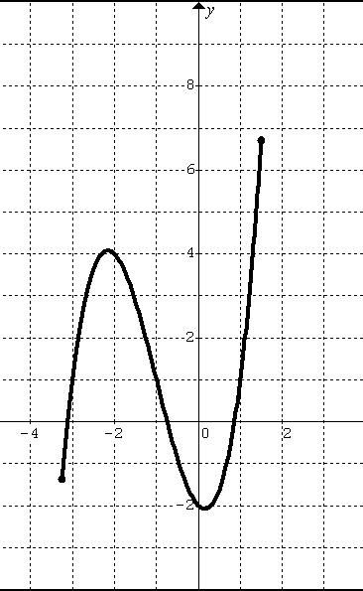 | A. Estimate the x value(s) where .  B. Estimate the x value(s) where .  C. Estimate the x value(s) where .  D. Estimate the x value(s) where .  E. Estimate the x value(s) where .  F. Estimate the x value(s) where .  G. Estimate the x value(s) where is decreasing.

7. Consider the derivative graph function shown below.
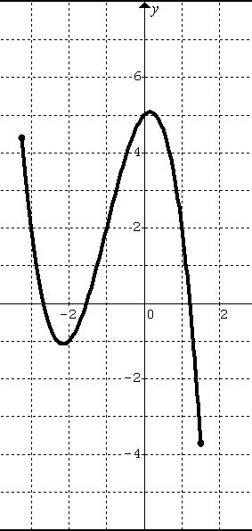 | A. Estimate the x-value(s) where f is increasing.  B. Estimate the x-value(s) where f is decreasing.  C. Estimate the x-value(s) where f is concave up.  D. Estimate the x-value(s) where f is concave down.

BC CALCULUS: Q201. [Derivative Applications] Lesson 4 – Chapter 4.4 Notes (Optimization)

NO – TECNOLOGY (BASIC “WHAT”)

1. A garden is to be laid out in a rectangular area and protected by a chicken wire fence. What is the largest possible area of the garden if only 100 running feet of chicken wire is available for the fence?

NO – TECNOLOGY (BASIC “WHERE”)

2. An open box is to be made from a 16-inch by 30-inch piece of cardboard by cutting out squares of equal size from four corners and bending up the sides. What size should the squares be to obtain a box with the largest volume?

TECHNOLOGY REQUIRED (BASIC “WHAT”)

3. A rectangle is to be inscribed under one arch of the cosine curve. What is the largest area the rectangle can have?

4. NO TECHNOLOGY []

Find a point on the curve that is closest to the point (18,0).

5. NO TECHNOLGY [relationship]

Find the radius and height of the right cylinder of largest volume that can be inscribed in a right circular cone with radius 6 inches and height 10 inches.

HOMEWORK

NO TECHNOLOGY

1. What is the smallest perimeter possible for a rectangle whose area is 16 cm², and what are its dimensions?

2. A rectangular plot of farmland will be bounded on one side by a river and on the other three sides by a single-strand electric fence. With 800 m of wire at your disposal, what is the largest area you can enclose, and what are its dimensions?

3. A rectangle has its base on the x-axis and is inscribed under the curve .
What is the largest area a rectangle can have, and what are its dimensions?

TECHNOLOGY REQUIRED

4. Find where (a point) on the curve that is closest to the point (4,0).

5. A rectangle is to be inscribed under the arch of the curve from to . What is the largest area of this rectangle can have?

6. A rectangle has its base on the x-axis and is inscribed under the curve .
What is the largest area of this rectangle can have?

NO TECHNOLOGY (REVIEW)

What values of a and b make have a local minimum at and a point of inflection at .

BC.Q201.LESSON5.NOTES: Theorems that Guarantee
MEAN VALUE THEOREM
If f is continuous on the closed interval [a, b] and differentiable on the open interval (a, b), then there exist at least one point x = c in (a, b) such that:

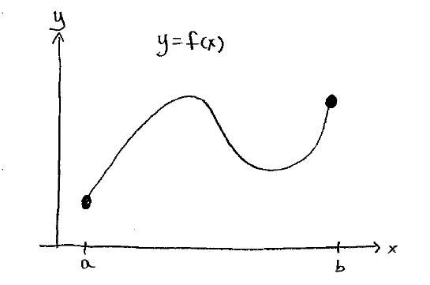
EXAMPLES:
1. If it applies, find the value(s) of c that satisfy the Mean Value Theorem.

EXTREME VALUE THEOREM
If f is continuous on the closed interval [a, b], then f has both an absolute maximum and absolute minimum on the interval.

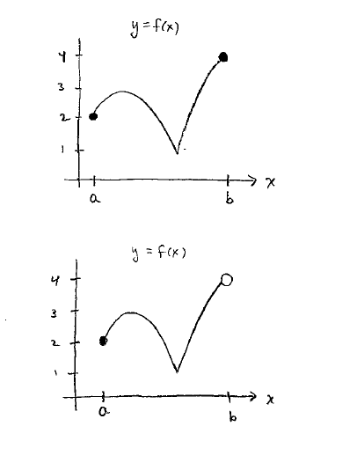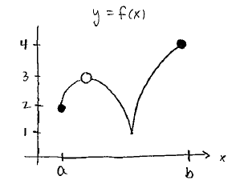

INTERMEDIATE VALUE THEOREM
If f is continuous on the closed interval [a, b], then f takes on every value betweenand.
If f / is continuous on the closed interval [a, b], then f / takes on every value between and .
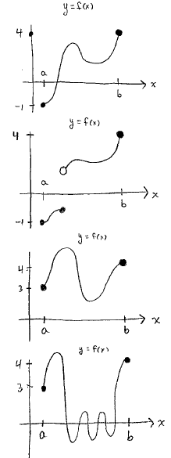

BC.Q201.DERIVATIVE APPLICATIONS – LESSON 5 (PRACTICE)
(NO CALCULATOR – UNLESS NOTED OTHERWISE)

1. Determine whether f satisfies the hypothesis of the Mean Value Theorem on [a, b], and, if so, find all numbers c in (a, b) that satisfy the conclusion of the Mean Value Theorem.

A. NO CALCULATOR on [0,1]

B. NO CALCULATOR on [2, 4]

C. TECHNOLOGY REQUIRED: on [1.5, 3] (round answer to three places)

2. NO CALCULATOR 1989 – AB 1:

Let f be the function given by.

- Find the zeros of f.
- Write an equation of the tangent to the graph of f at .
- Find the number c, that satisfies the conclusion of the Mean Value Theorem for f on the closed interval [1, 3]

