Provide a careful sketch of each parent function:
1. $f(x)=x$
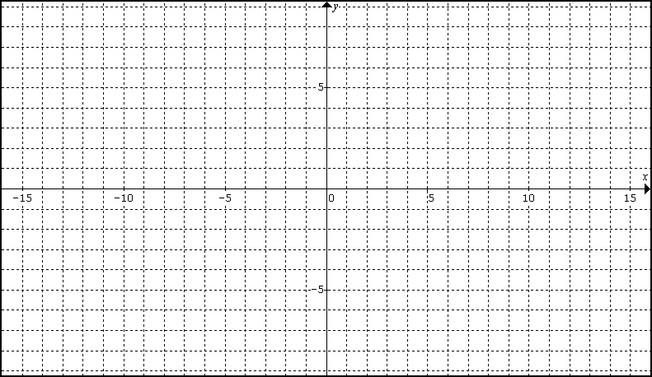
b. Let $y=2x−1$. Use function notation to represent y in terms of f.
Describe the transformation of f to obtain y. Graph y.

2. $g(x)=x^{2}$
b. Let $y=−\frac{1}{2}{\left(x+3\right)}^{2}+2$. Use function notation to represent y in terms of g.
Describe the transformation of g to obtain y. Graph y.

3. $h(x)=2^{x}$
b. Let $y=2^{−x}−8$. Use function notation to represent y in terms of h.
Describe the transformation of h to obtain y. Graph y.
4. $k(x)={\text{log}}_{2}x$
b. Let $y={\text{log}}_{2}\left(x+6\right)$. Use function notation to represent y in terms of k.
Describe the transformation of k to obtain y. Graph y.

5. $p(x)=\frac{1}{x}$
b. Let $y=\frac{1}{x−5}$. Use function notation to represent y in terms of p.
Describe the transformation of p to obtain y. Graph y.

6. $m(x)=\sqrt{x}$
b. Let $y=5−2\sqrt{3−x}$. Use function notation to represent y in terms of m.
Describe the transformation of m to obtain y. Graph y.

