4. Consider the cubic polynomial $p(x)={\text{ax}}^{3}+{\text{bx}}^{2}+\text{cx}+d=(0\text{.}2)\left(a_{1}x^{3}+b_{1}x^{2}+c_{1}x+d_{1}\right)$ below.
Write the function in factored form.
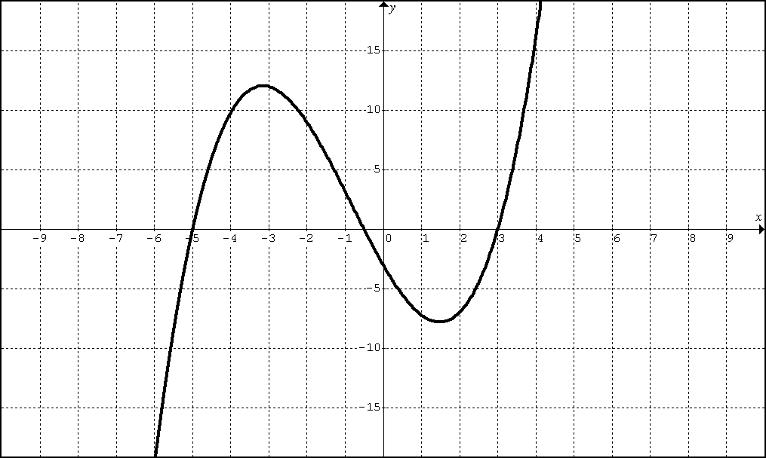

5. Consider the quartic polynomial $r(x)={\text{ax}}^{4}+{\text{bx}}^{3}+{\text{cx}}^{2}+\text{dx}+e=(0\text{.}\text{06})\left(a_{1}x^{4}+b_{1}x^{3}+c_{1}x^{2}+d_{1}x+e_{1}\right)$below.
Write the function in factored form.
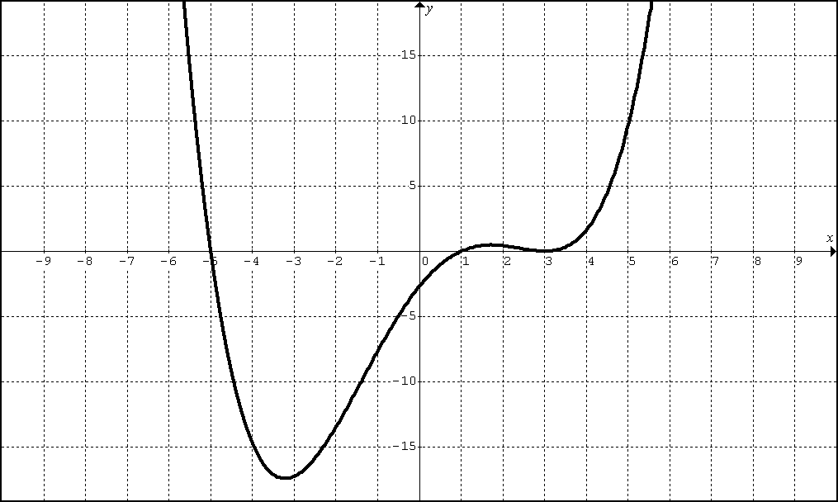

6. Now go back and find the equations in standard form.
1. Consider the cubic polynomial $f(x)={\text{ax}}^{3}+{\text{bx}}^{2}+\text{cx}+d$below.
Write the function in factored form.
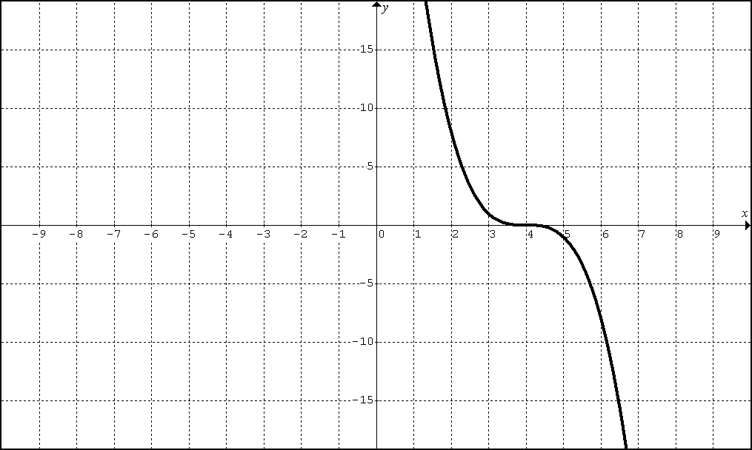

2. Consider the cubic polynomial $g(x)={\text{ax}}^{3}+{\text{bx}}^{2}+\text{cx}+d$below.
Write the function in factored form.
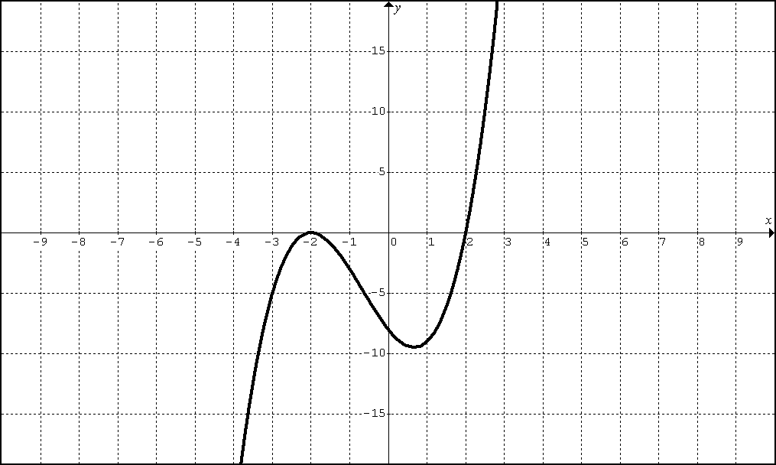

3. Consider the quartic polynomial $h(x)={\text{ax}}^{4}+{\text{bx}}^{3}+{\text{cx}}^{2}+\text{dx}+e$below.
Write the function in factored form.
