1. A Koch snowflake is constructed by taking each side of an equilateral triangle and making an equilateral triangle from the middle third of each side, removing the base of the new triangle. The diagram below shows four such stages of construction.
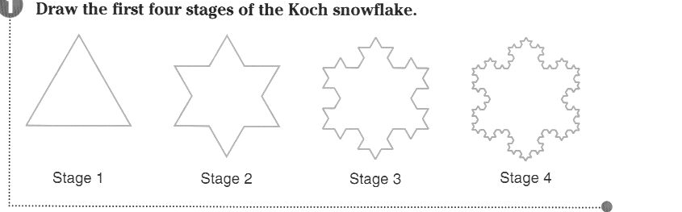
A1. Construct a sequence that tells the number of line segments at each stage n.
A2. What type of sequence is this?
A3. What is the nth term of this sequence?
A4. How many line segments are there at the 21st stage?

B1. If the length of each segment at Stage 1 is 9 units, construct a sequence that represents the length of each segment at each stage n.
B2. What type of sequence is this?
B3. What is the nth term of this sequence?
B4. What is the length of each segment at stage 21?

C1. If the length of each segment at Stage 1 is 9 units, construct a sequence that represents the perimeter of the snowflake at each stage n.
C2. What type of sequence is this?
C3. What is the nth term of this sequence?
C4. What is the perimeter at stage 21?
C5. What is the perimeter at an infinite stage? Explain your answer.

2. Sierpinski’s Triangle is constructed as follows:
- Start with an equilateral triangle.
- Connect the midpoints of the sides with line segments.
- Remove the middle triangle.
- Apply steps to 1 – 3 to each of the remaining triangles repeatedly.

Sierpinski’s Triangle
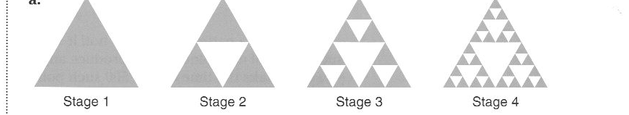

A1. If the area of the triangle at Stage 1 is 64 square units, construct a sequence that represents the area at each stage n.
A2. What type of sequence is this?
A3. What is the nth term of this sequence?
A4. What is the area at stage 18?
A5. What is the area at an infinite stage? Explain your answer.

B. Construct your own sequence using Sierpinski’s Triangle.

