1. Graph  Range:  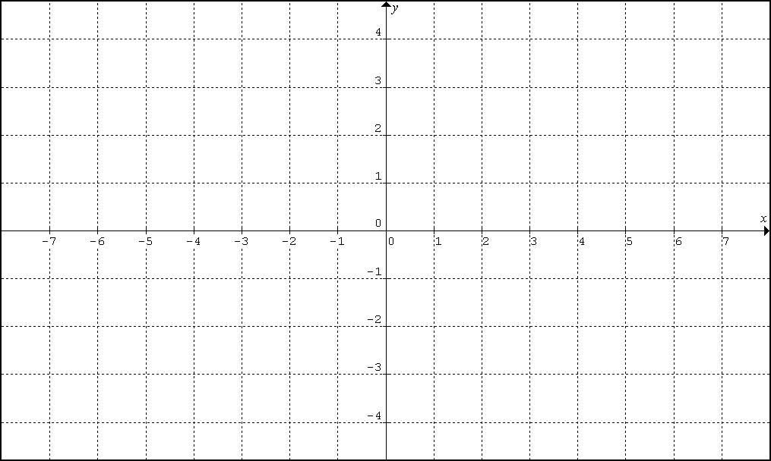 | 2. Graph for D:  Range:
3. Graph for D:  Range: | 4. Graph for D:  Range:
5. Graph for D:  Range: | 6. Graph for D:  Range:

7. Graph  Range: | 8. Graph for D:  Range:
9. Graph for D:  Range: | 10. Graph for D:  Range:
11. Graph for D:  Range: | 12. Graph for D:  Range:

13. Graph  Range: | 14. Graph for D:  Range:
15. Graph for D:  Range: | 16. Graph for D:  Range:
17. Graph for D:  Range: | 18. Graph for D:  Range:

19. Graph | 20. Graph
21. Graph | 22. Graph
23. Graph | 24. Graph

