Write each of the following absolute value functions in simplified piecewise format.

Graph each of the following functions.
1.  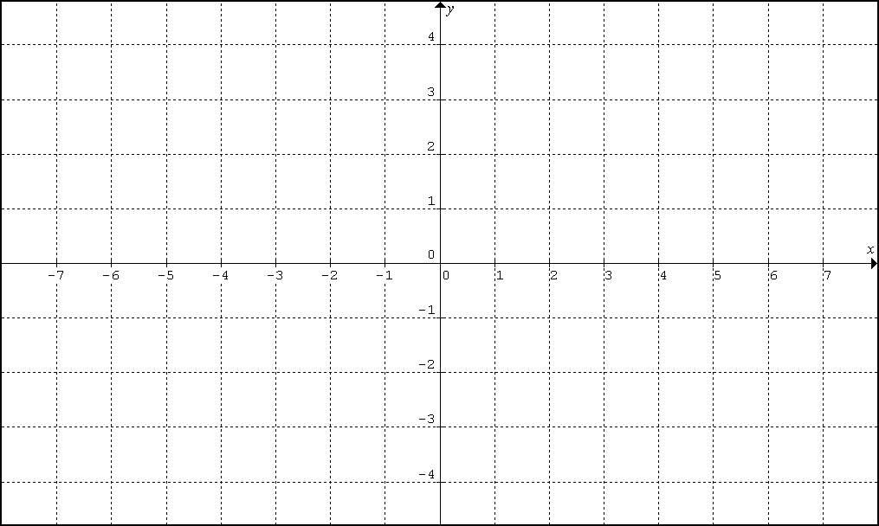 | 2.
3. | 4.

