1. Graph  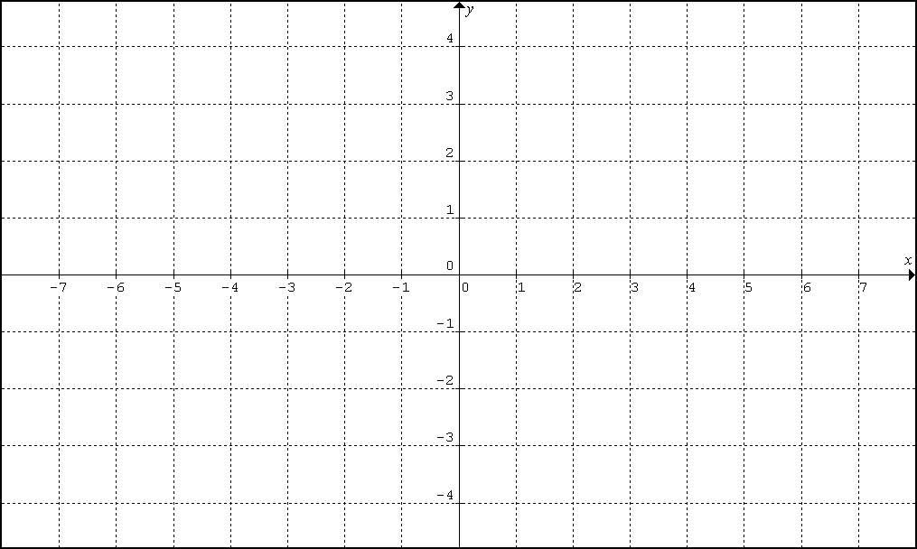 | 2. Graph
3. Graph | 4. Graph

