(a) State the domain and range of each function below.
(b) Draw the inverse of each function.
(c) Determine if the inverse is a function.
(d) State the domain and range of each inverse.
1.  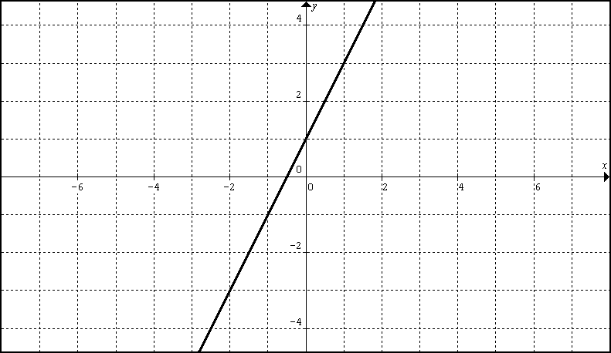 | 2.  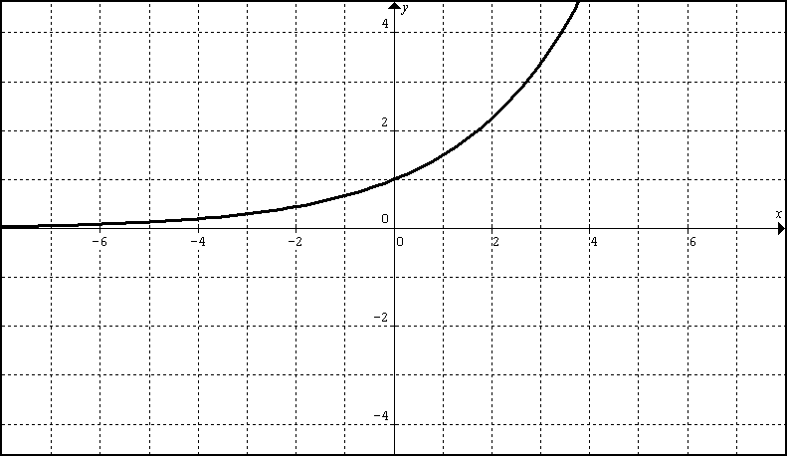
3.  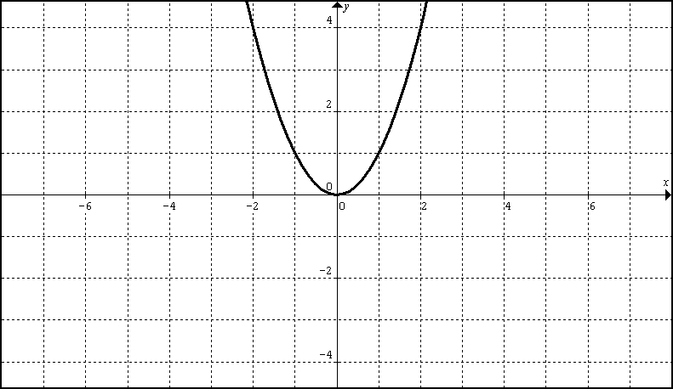 | 4.  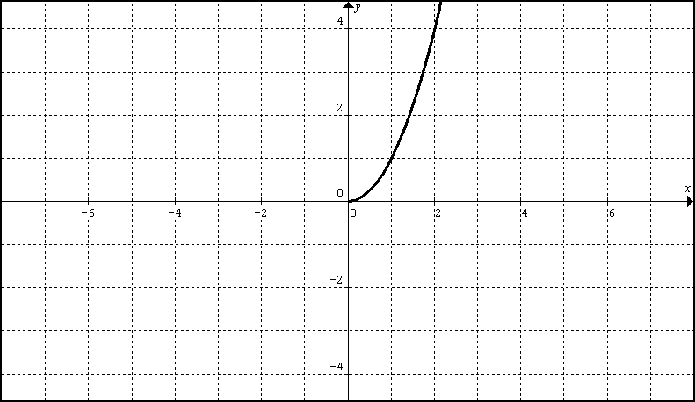
5.  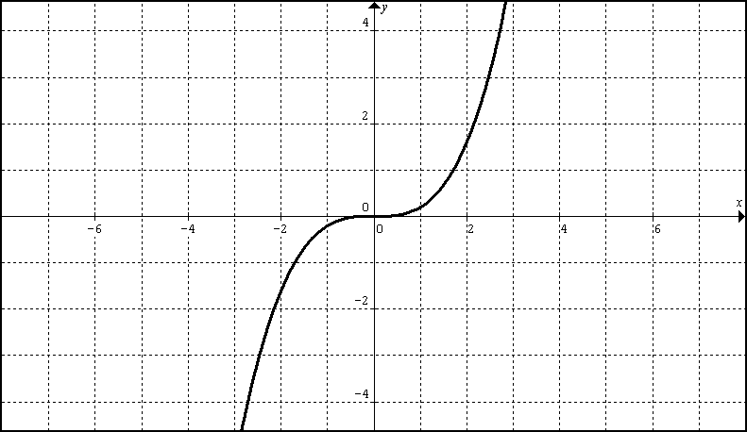 | 6.  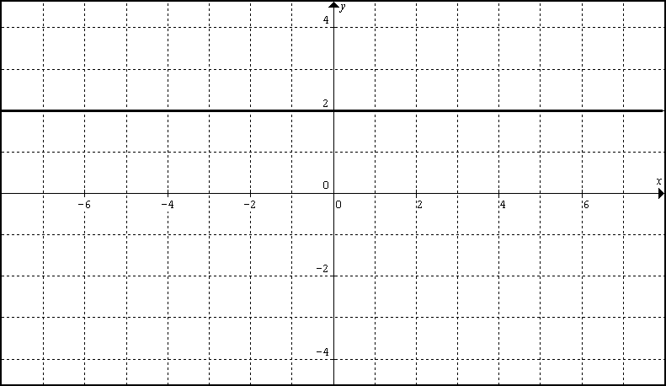
Find the inverse function of each linear equation:

1. $f(x)=−x+5$

2. $f(x)=\frac{1}{2}x−3$

3. $f(x)=\frac{x}{3}+7$

4. $f(x)=\frac{3x−5}{2}$

5. $f(x)=4−2x$

Find the inverse function for each of the following functions:

6. $f(x)=\sqrt{x}$

7. $f(x)=−5$

8. $f(x)=\frac{\sqrt{x}}{2}−8$

