Use a table of values to graph the following function. State the natural domain and range of each.

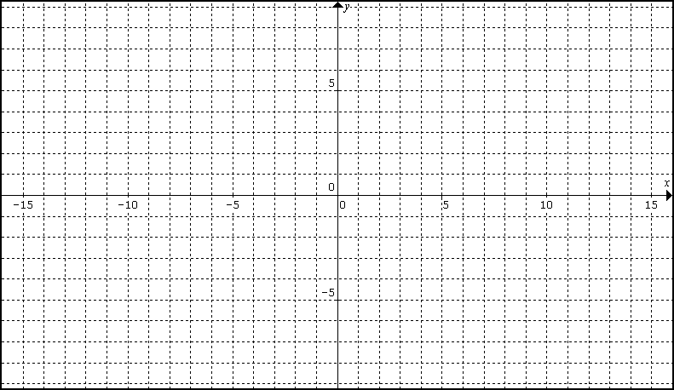
$$y=x$$ | $$y=\left|x\right|$$
$$y=x^{2}$$ | $$y=\sqrt{x}$$

