Consider each function y = f (x) below.
Evaluate each expression and find the value of x that makes the equation true.
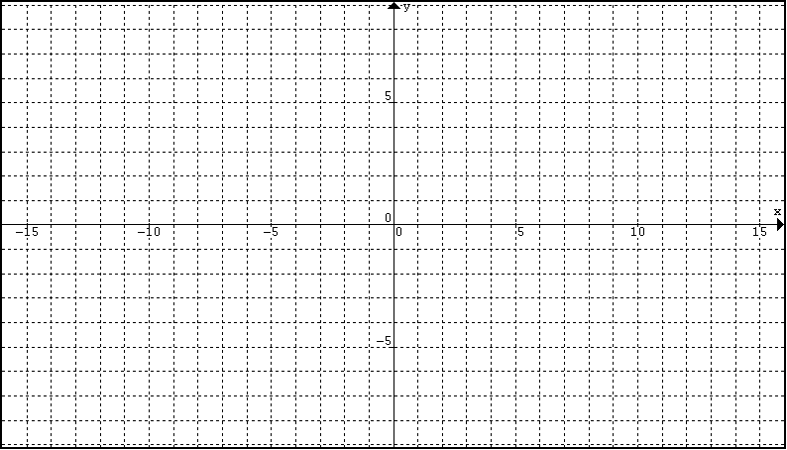
1
2
1) f(4) f(0) f( -2) f(-10) 2) f(-10) f(0) f(5) f(10)

1) f(x) = 1 f(x) = -3 f(x) = 0 2) f(x) = 4 f(x) = -4 f(x) = 0

4
3
3) f(4) f(0) f( -2) f(-10) 4) f(-8) f(0) f(5) f(10)

3) f(x) = 1 f(x) = 3 f(x) = 0 4) f(x) = 4 f(x) = -4 f(x) = 0

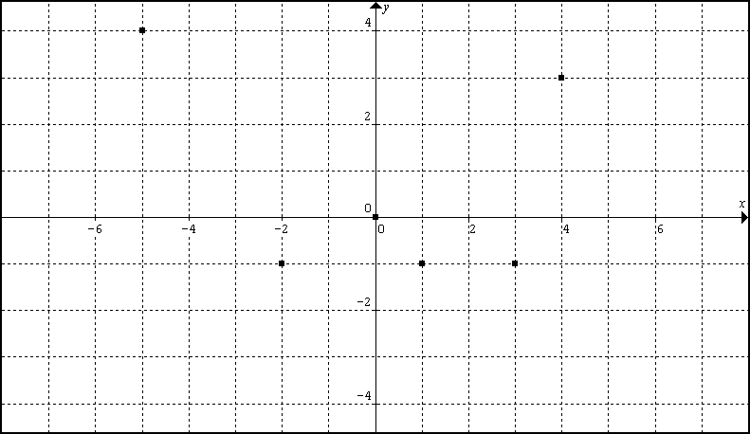
5
6
5) f(4) f(0) f( -2) f(-10) 6) f(-10) f(0) f(5) f(10)

5) f(x) = 1 f(x) = -1 f(x) = 3 6) f(x) = 4 f(x) = -4 f(x) = 0

