Consider each function below and state the domain and range of each.
Also state whether the function is continuous or not continuous.
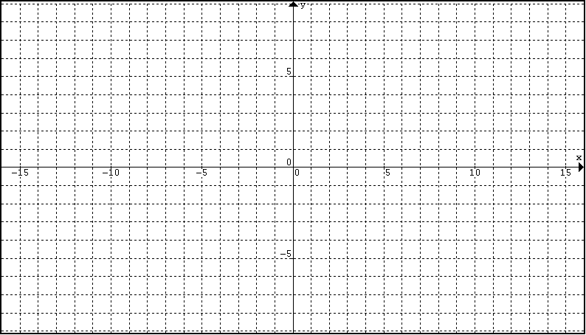
1
2
Domain: Domain:

Range: Range:

4
3
Domain: Domain:

Range: Range:

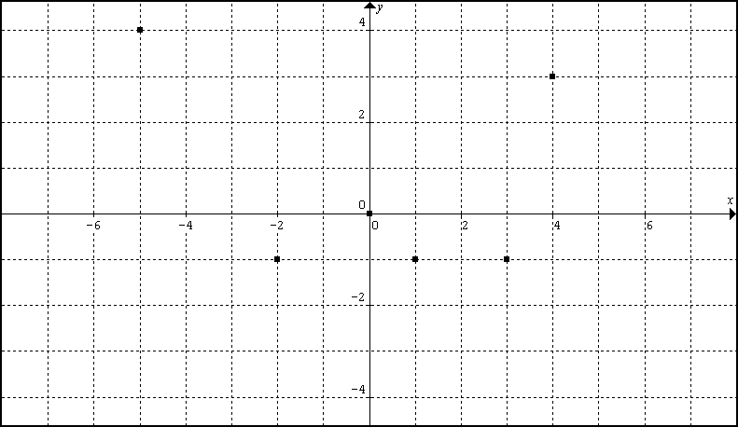
5
6
Domain: Domain:

Range: Range:

