Determine mathematically whether each function is even, odd or neither. Show work.

1. 2. 3. 4.

5. 6. 7. 8.

9. 10.
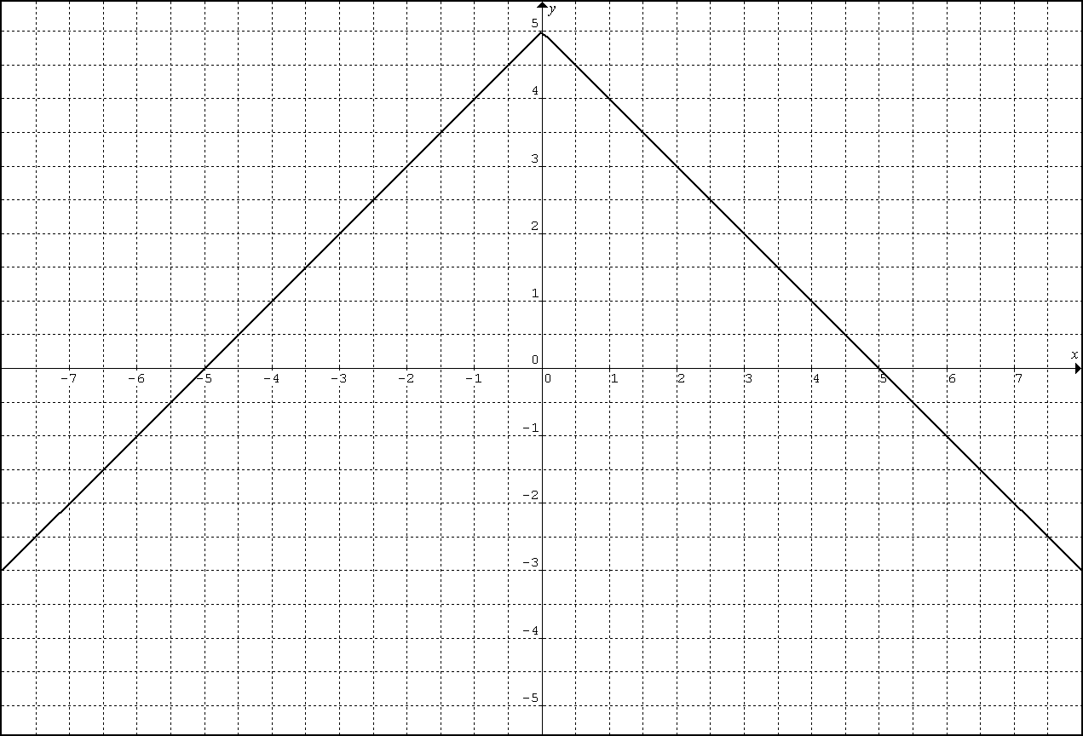  11. | 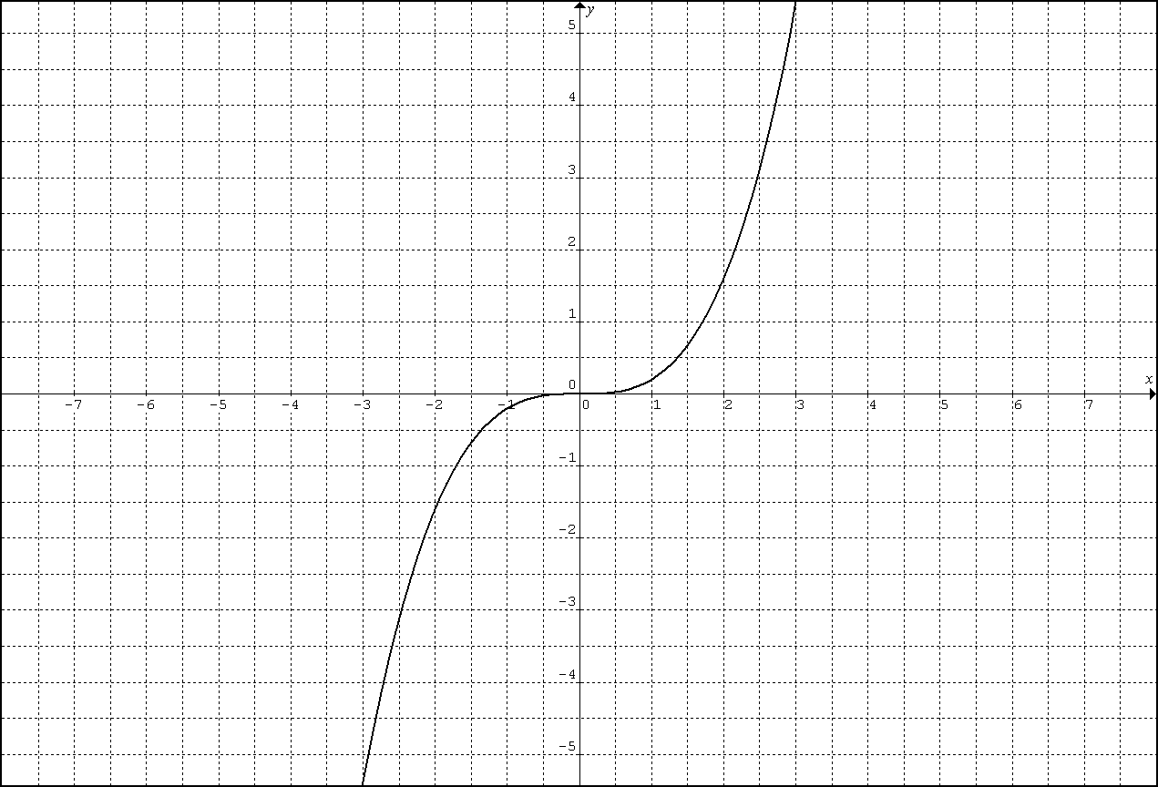  12.
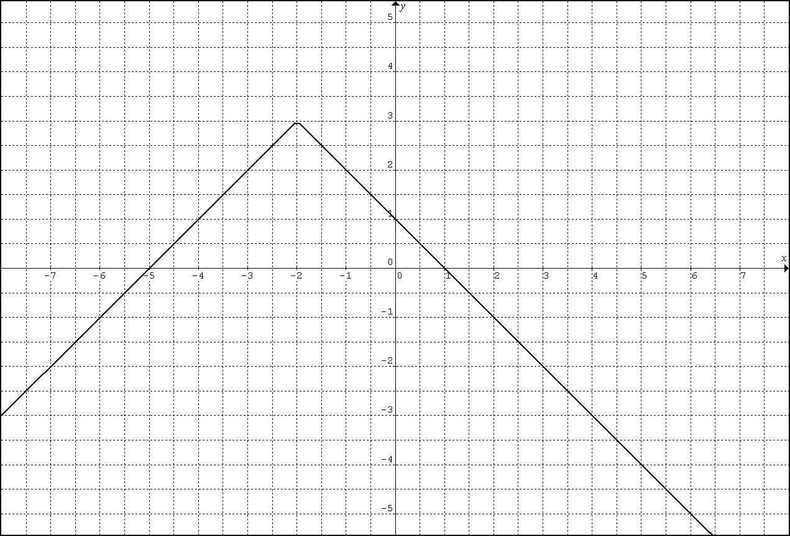 | 