Objectives: Students will be able to…
- Define appropriate matrices from a system of equations
- Write matrix equations that can be used to solve for missing variables
- Enter matrices into the TI84 calculator
- Solve a system of equations using the matrix functions of the TI84 calculator

Step 1: To solve a system of equation using matrices, one must first define three matrices: (1) a matrix of coefficients [A], (2) a solution matrix $\left[\begin{matrix}x \\ y\end{matrix}\right]$ or $\left[\begin{matrix}x \\ y \\ z\end{matrix}\right]$and (3) a matrix of constants [B].
For example consider the systems

S1 = $\begin{aligned}\left\{2x−5y=−4 | \right.\end{aligned}$ | S2=$\begin{aligned}\left\{x−3y+z=−\text{21} | \right.\left\{2x−y+z=−9 | \right.\end{aligned}$
In system S1, the required matrices are as follows:  (1) $[A]=\left[\begin{matrix}2 & −5 \\ 6 & \text{10}\end{matrix}\right]$ (this is a $2×2$matrix)  (2) $\left[\begin{matrix}x \\ y\end{matrix}\right]$  (3) $[B]=\left[\begin{matrix}−4 \\ 3\end{matrix}\right]$ (this is a $2×1$ matrix) | In system S2, the required matrices are as follows:  (1) $[A]=\left[\begin{matrix}1 & −3 & 1 \\ 2 & −1 & 1 \\ 2 & 1 & 5\end{matrix}\right]$ (this is a $3×3$matrix)  (2) $\left[\begin{matrix}x \\ y \\ z\end{matrix}\right]$  (3) $[B]=\left[\begin{matrix}−\text{21} \\ −9 \\ −\text{31}\end{matrix}\right]$ (this is a $3×1$matrix)
The matrix equation is $\left[\begin{matrix}2 & −5 \\ 6 & \text{10}\end{matrix}\right]⋅\left[\begin{matrix}x \\ y\end{matrix}\right]=\left[\begin{matrix}−4 \\ 3\end{matrix}\right]$  Which is equivalent to $[A]⋅\left[\begin{matrix}x \\ y\end{matrix}\right]=[B]$  $[A]^{−1}$means multiplication inverse of matrix A  Which means our solution is $\left[\begin{matrix}x \\ y\end{matrix}\right]=[A]^{−1}⋅[B]$ | The matrix equation is $\left[\begin{matrix}1 & −3 & 1 \\ 2 & −1 & 1 \\ 2 & 1 & 5\end{matrix}\right]⋅\left[\begin{matrix}x \\ y \\ z\end{matrix}\right]=\left[\begin{matrix}−\text{21} \\ −9 \\ −\text{31}\end{matrix}\right]$  Which is equivalent to $[A]⋅\left[\begin{matrix}x \\ y \\ z\end{matrix}\right]=[B]$.  Which means our solution is $\left[\begin{matrix}x \\ y \\ z\end{matrix}\right]=[A]^{−1}⋅[B]$
Step 2: We must now enter our (1) coefficient matrix and (2) constant matrix into our TI84.
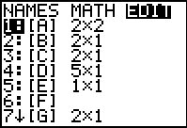
For system S1…

(a) Enter the coefficients into matrix [A]
Directions:
2nd Matrix > Edit 1:[A]
<enter $2×2$as the dimensions>
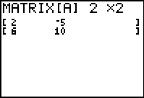
<enter the coefficients as described in step 1>

(b) Enter the constants into matrix [B]
Directions:
2nd Matrix > Edit 1:[B]
<enter $2×1$as the dimensions>
<enter the constants as described in step 1>

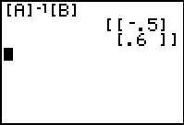
Step 3: Find the solution matrix
Directions:
<Start at the home screen>
2nd Matrix Names 1:[A] (matrix [A] will appear on the home screen)
<press the inverse key $x^{−1}$> ($[A]^{−1}$will appear on the home screen)
The solution is $(x=−0\text{.}5,y=0\text{.}6)$
2nd MATRIX NAMES 2:[B] ($[A]^{−1}$[B] will appear on the home screen)
<enter> (this will display the solution)

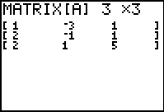
For system S2…

(a) Enter the coefficients into matrix [A]
Directions:
2nd Matrix > Edit 1:[A]
<enter $3×3$as the dimensions>
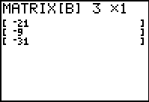
<enter the coefficients as described in step 1>

(b) Enter the constants into matrix [B]
Directions:
2nd Matrix > Edit 1:[B]
<enter $3×1$as the dimensions>
<enter the constants as described in step 1>

Step 3: Find the solution matrix
Directions:
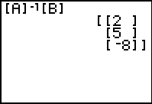
<Start at the home screen>
2nd Matrix Names 1:[A] (matrix [A] will appear on the home screen)
<press the inverse key $x^{−1}$> ($[A]^{−1}$will appear on the home screen)
2nd MATRIX NAMES 2:[B] ($[A]^{−1}$[B] will appear on the home screen)
<enter> (this will display the solution)
The solution is ($x=2,y=5,z=−8$)

