Objectives: Students will be able to…
(1) define an array of equations in the Y= menu; including linear, quadratic, absolute value, and square root functions
(2) change window settings to allow for optimal viewing of defined functions
(3) graph one or more functions defined in the Y= menu (including thick lines opposed to thin lines)
(4) use calc menu option to evaluate functions at given values of x
(5) use calc menu option to evaluate a maximum or minimum value of a function which assists when defining a range

Task #1: Store the following functions to graph:
$y=−2x+3$, $y=2x^{2}−4x+5$, $y=|x−2|−4$, $y=\frac{6}{x−3}$, $y=\sqrt{x−3}$, $y=−\frac{1}{2}|x+\text{12}|+5$
Directions:

1) Press the Y = key on the top row of buttons
2) Type in the equations as y1, y2, etc.

Note 1: Use the negative key (next to enter) for negative signs such as the negative 2 in$Y_{1}=−2x+3$

Note 2: Use the minus key (above “+”) for subtraction as in the minus 4x in $Y_{2}=2x^{2}−4x+5$.

Note 3: Use abs( ) for absolute value. Press the MATH key / right arrow key > for NUM/ enter “1” for 1:abs(
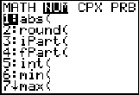
Figure 1.1
Note 4: Be sure to use parentheses around quantities in a numerator or denominator such (x – 3) in $Y_{4}=\frac{6}{x−3}$
Type: 6/(x – 3) WHY? That is, why not type: 6/x – 3

Note 5: Why should we type $Y_{5}=\sqrt{}(x−3)$instead of $Y_{5}=\sqrt{}(x)−3$?
Note 6: Use parentheses around fraction coefficients such as in $Y_{6}=−\frac{1}{2}|x+\text{12}|+5$
Type: -(1/2)abs(x+12)+5
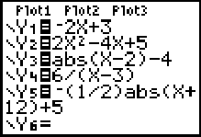
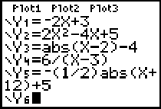

Figure 1.2
Figure 1.3

Note 7: You will notice that in Figure 1.2 all the equal signs are highlighted. This indicates that all functions will be graphed simultaneously. Eventually we want to graph one at a time so we want to remove these highlights. Move the curser over each equal sign and press “enter” to remove the highlight as in Figure 1.3.
Task 2: Adjust the window setting

Directions: Because many functions have interesting behavior around the origin, the standard window setting is centered around (0,0) with the x-axis extending from –10 to 10 and the y-axis extending from –10 to 10 where each hash mark represents 1 unit. To set the window to this standard setting press the “WINDOW” key and enter the boundaries as in Figure 2.1 or press the “ZOOM” key followed by “6” for 6:Zstandard.

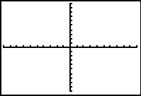
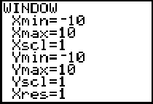
Figure 2.1

Some functions are graphed outside the standard window so adjustments must be made to see the graph. For example, $Y_{6}=−\frac{1}{2}|x+\text{12}|+5$ cannot be viewed using the standard window setting. Figure 2.2 shows a better window setting where we can easily view the “V” shape.
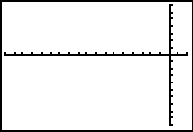
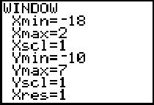
Figure 2.2

Task 3: Graph each function, one at a time.

Directions: Move the curser over the equal sign and press “enter” to highlight it. Press the “GRAPH” key.

Note 1: Undo the highlight before graphing the next function
Note 2: Use the standard window setting for functions Y1 to Y5 and the adjusted window setting (Fig. 2.2) for Y6
Note 3: A graph line can be thick opposed to thin. Direction: Move the curser to the left of the Y in the Y= window and press “enter” until the line shows a thick line. This will make the graph line thick. See Figure 3.1.
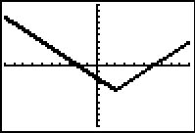
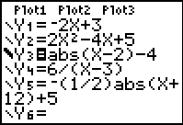
Figure 3.1

Task 4: Graph Y2 on the window setting $\left\{−2≤x≤4\right\}$ and $\left\{−1≤y≤\text{20}\right\}$and evaluate the values of y associated with the x-values x = -1.5, 2.5, and 3.25.

Direction: Adjust the window. Graph Y2. Press the “2nd” key followed by the “CALC” key. Press “1” for option 1:value. Enter the x value “– 1.5” and notice that the calculator returns y = 15.5 Fig4.1. Now enter “2.5” then “3.25” to get the respective y values.

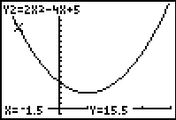
Figure 4.1

Task 5: Graph Y2 and find the minimum value of Y.

Directions: It appears that the minimum value of y is 3 and hence, the range $y≥3$. Let us verify this.
Graph Y2. Press the “2nd” key followed by the “CALC” key. Press “3” for option 3:minimum. Use the left arrow key to move the curser to the left of the vertex and press “enter”. Now use the right arrow key to move the curser to the right of the vertex and press “enter”. Press “enter” a third time and the calculator will return the minimum y value. In fact, the minimum value of y is 3!

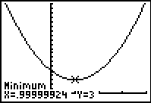
Figure 4.2

