Task 1: Graph $y=|x|$ (in pencil), $y=|x|+2$(in blue pen or pencil), and $y=|x|−4$(in red pen or pencil) on the window setting $\left\{−5≤x≤5\right\}$ and $\left\{−5≤y≤5\right\}$
Label each vertex as an ordered pair.

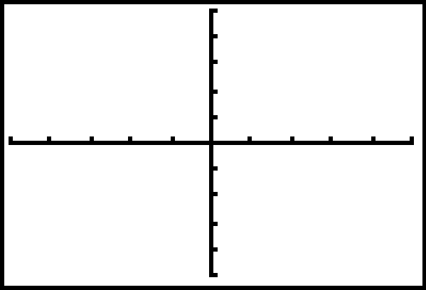

Question 1: Consider the function $y=|x|+k$. What influence does k have on the function $y=|x|$? Use clear complete sentences to describe the effect of k (include the word “shift”).

Task 2: Graph $y=|x|$ (in pencil), $y=|x+3|$(in blue pen or pencil), and $y=|x−1|$(in red pen or pencil) on the window setting $\left\{−5≤x≤5\right\}$ and $\left\{−5≤y≤5\right\}$
Label each vertex as an ordered pair.

Question 2: Consider the function $y=|x−h|$. What influence does h have on the function $y=|x|$? Use clear complete sentences to describe the effect of h.

Task 3: Describe, in words, the translation of $y=|x|$to $y=|x+4|−1$. What is the vertex of $y=|x+4|−1$?

Task 4: Write the equation for the function graphed below.
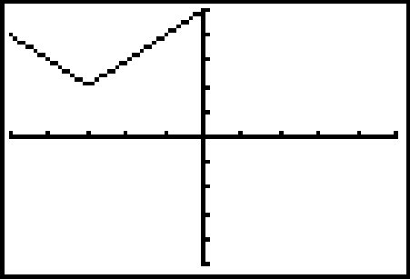

$$y=$$

Task 5: Write the equation for the function graphed below.
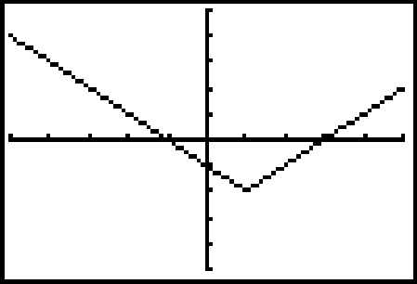

$y=$
Task 6: Graph $y=2x^{2}−3\text{.}5x+3\text{.}1$and state the range, rounding values to the nearest hundredths. Range:

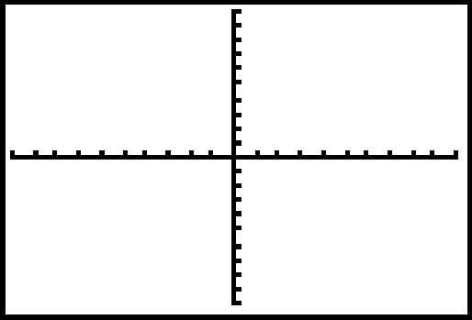

Task 7: Graph $y=−x^{2}+5\text{.}4x+\text{10}$and state the range, rounding values to the nearest hundredths. Range:

